University of Nairobi
Faculty of Law- Centre for Maritime Studies/Fish Force Academy

DRAFT SECTOR REPORT (2023-24)
CONSTRUCTION AND INFRASTRUCTURE SECTOR

WIOMSA Grant Supported Project
Grant No: CITIES/COASTS/OP/2020/02

Title: REALIZING A BLUE URBAN AGENDA FOR COASTAL CITIES IN KENYA THROUGH SUSTAINABLE CONSUMPTION AND PRODUCTION POLICY AND GOVERNANCE

TABLE OF CONTENTS

ABBREVIATIONS AND ACRONYMS 3
LIST OF FIGURES 5
LIST OF MAPS 6
LIST OF TABLES 7
CHAPTER ONE 8
INTRODUCTION AND CONTEXT 8
1.1 Introduction 8
1.2 Project Context 10
CHAPTER TWO 13
SITUATIONAL AND GAP ANALYSIS IN THECONSTRUCTION AND INFRASTRUCTURE SECTOR 13
2.1 Introduction 13
2.2 National and Regional Development Priorities 15
2.3 Overview of the Selected Project Sites 19
2.3.1 Mombasa County 19
2.3.2 Kwale County 24
2.3.3 Kilifi County 27
2.4 Review of Relevant International and National SCP Relevant Legal, Policy and Other Governance Frameworks 29
2.4.1 International Legal Framework 29
2.4.2 Regional Legal Framework 30
2.4.3 National Legal and Policy Frameworks 31
2.4.4 Sub-National Legal Framework 36
CHAPTER THREE 39
KEY FINDINGS 39
3.1 Analysis of Desktop Reviews 39
3.2 Analysis of field based responses 45
3.2.1 Kwale: Director of Urban and Physical Planning – Diani Municipality 46
3.2.2 National Construction Authority – Deputy Regional Co-ordinator 47
3. 3 Key findings and observations 48
CHAPTER 4 50
BEST PRACTICES AND LESSONS FROM OTHER JURISDICTIONS 50
4.1 Integrating environmental and social considerations in the construction and infrastructure projects. 50
4.2 Sustainable Procurement in the Construction Industry 51
4.3 The ASEAN Countries Sustainable Urbanization Strategy 51
4.4 Inter-American Development Bank: the four dimensions of infrastructure sustainability 52
4.5 UN-DESA Integrated Strategy for Sustainable Cities 2013 52
4.6 The Green City Index 53
CHAPTER 5: 55
PROPOSED OPTIONS AND RECOMMENDATIONS 55
REFERENCES 63

ABBREVIATIONS AND ACRONYMS
AFREC: The African Energy Commission
ADP: Annual Development Plan
ASEAN: Association of Southeast Asian Nations
AU: African Union
BMU: Beach Management Unit
CIDP: County Integrated Development Plan
EAC: East African Community
EEZ: Exclusive Economic Zone
EMS: Environmental Management System
EPR: Extended Producer Responsibility
FGD: Focus group discussion
GHG: Greenhouse gas
UN Habitat III: The Third United Nations Conference on Housing and Sustainable Urban Development
IBC: International Building Code
IgCC: International Green Construction Code
IPCC: Intergovernmental Panel on Climate Change
JICA: Japan International Cooperation Agency
JKP: Jumuiya ya Kaunti za Pwani
KBRC: Kenya Building Research Centre
KeNHA: Kenya National Highways Authority
KeRRA: Kenya Rural Roads Authority
KFSL: Kenya Ferry Services Limited
KPA: Kenya Ports Authority
KURA: Kenya Urban Roads Authority
M&E: Monitoring and Evaluation
MICE: Meetings, Incentives, Conferences and Exhibitions
MSME: Micro, Small and Medium Enterprises
MTP: Medium Term Plan
NaCRA: The National Construction Research Agenda
NCA: National Construction Authority
NSP: The National Spatial Plan
NUA: The New Urban Agenda
OSR: Own Source Revenue
PFM: Public Finance Management
PPP: Public-Private Partnership
PWDs: Persons with disabilities
REREC: Rural Electrification and Renewable Energy Corporation
SCP: Sustainable Consumption and Production
SDG: Sustainable Development Goal
SEZ: Special Economic Zone
SPV: Special Purpose Vehicle
UN DESA: United Nations Department of Economic and Social Affairs
UNEP: United Nations Environment Programme
UNFCCC: United Nations Framework Convention on Climate Change
UN-Habitat: The United Nations Human Settlements Programme
WIO: Western Indian Ocean

LIST OF FIGURES
Figure 1: Elements of SCP 9
Figure 2: Summary of construction and infrastructure projects in the JKP region 11
Figure 3: Construction and infrastructure project life cycle 12
Figure 4: Conceptual Framework for ensuring SCP in construction and infrastructure projects 12
Figure 5: Summary of Planning and Development Frameworks Sampled 14
Figure 6: Small jetty at Shimoni Fishing Port in Kwale County 25
Figure 7: Ramisi Sugar Mill in Kwale County 27
Figure 8: Milestones in International Environmental Law 40
Figure 9: Analysis of sampled Global Frameworks addressing different elements of SCP 42
Figure 10: Analysis of sampled Regional Frameworks addressing different elements of SCP 43
Figure 11: Analysis of sampled National Frameworks addressing different elements of SCP 43
Figure 12: Analysis of sampled Sub-National Frameworks addressing different elements of SCP 44
Figure 13: Infrastructure development in cities 53
Figure 15: Life Cycle Approach in Construction and Infrastructure 58
Figure 16: Life Cycle Approach to construction waste management 59
Figure 17: Life Cycle Approach to Policy Options and Recommendations 62

LIST OF MAPS
Map 1: Project Sites: 8
Map 2: National Spatial Plan Conceptual Framework 16
Map 3: Map of the JKP Economic Bloc 17
Map 4: Administrative Units in Mombasa County 19
Map 5: Administrative Units in Kwale County 24
Map 6: Administrative Units in Kilifi County 28

LIST OF TABLES
Table 1: JKP Flagship Projects (2019-2030) 18
Table 2: Mombasa County Priority Projects by sector 21
Table 3: Mombasa County CIDP Priority Areas 22

CHAPTER ONE

INTRODUCTION AND CONTEXT

1.1 Introduction
The project on “Realizing a Blue Urban Agenda for Coastal Cities in Kenya Through Sustainable Consumption and Production Policy and Governance” addressed four (4) sectors in three project sites in Mombasa, Kwale and Kilifi counties (Map 1). The sectors are agriculture and food processing, tourism and hospitality, construction and infrastructure, and environment and natural resources.
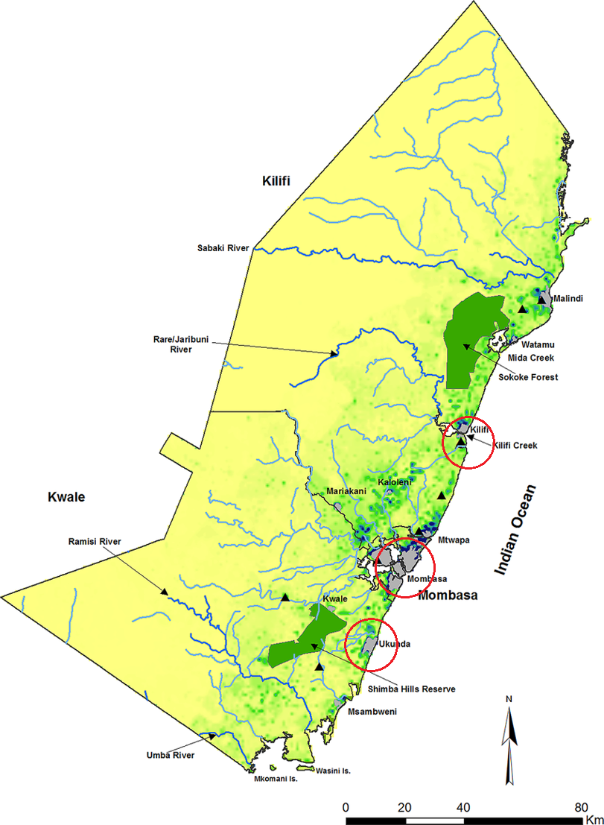
Map 1: Project Sites:
Source: Adapted from https://www.researchgate.net/figure/The-Kenyan-coast-comprising-of-three-counties-Kilifi-Mombasa-and-Kwale-Showing_fig3_279304856

The main aim of this research project was to investigate how to integrate sustainable consumption and production (SCP) in Kenya’s coastal cities and urban areas, mainly through the coastal counties’ development plans, urban planning, legislation, regulatory frameworks, investments and policy decisions. In this regard, the research analysed global, regional, national and sub-national frameworks on SCP with a view to address policy, legal and institutional gaps and possible interventions. It also sought to present good practices on how SCP policy and governance can support the development and implementation of the Blue Urban Agenda for Kenya’s coastal region, and also to present possibilities for replication elsewhere in the Western Indian Ocean (WIO) region.
This research adopted the definition of SCP as ‘the use of services and related products, which respond to basic needs and bring a better quality of life while minimising the use of natural resources and toxic materials as well as the emissions of waste and pollutants over the life cycle of the service or product so as not to jeopardise the needs of future generations’ as illustrated in Figure 1 below.

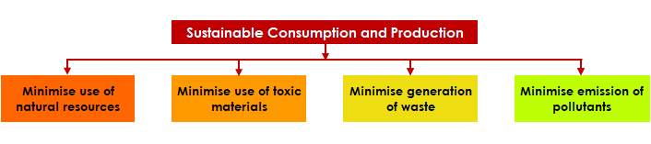
Figure 1: Elements of SCP
Source: Author (2024)

The goal of the project was to highlight the relevance of SCP policy and governance in developing and implementing a Blue Urban Agenda in Kenya coastal cities. The specific objectives were to:
- Identify the regulatory and governance gaps in the existing global, regional, national and sub-national policy framework on SCP in relation to the development and implementation of the Blue Urban Agenda;
- Investigate how to integrate SCP policies into coastal cities and urban areas’ development plans, urban planning, legislation, regulatory frameworks, investments and policy decisions in the Jumuiya ya Kaunti za Pwani (JKP) region;
- Present good practice examples of efforts and initiatives of coastal cities that are making tangible contributions towards implementing SCP; and
- Provide policy options and recommendations for developing and implementing the Blue Urban Agenda in the JKP region.

1.2 Project Context
This report focuses on the construction and infrastructure sector across the three project counties and sites namely Mombasa, Kwale (Ukunda/Diani) and Kilifi (Malindi). It forms part of a larger study that covers the other three sectors of concern (agriculture and food processing, tourism and hospitality, and environment and natural resources).
This sector includes development of physical infrastructure (commercial and industrial buildings, residential housing, institutional developments, road networks, rail systems, ports, airports, energy and telecommunications systems, water supply and sanitation systems, and solid waste management systems) as well as social infrastructure (hospitals and health centers, retail markets and shopping centers, education institutions, religious establishments, recreational facilities and open spaces) as illustrated in Figure 2 below.
Kenya’s coastal region exhibits the current global trends of rapid and unprecedented urbanization. This rapid urban (and largely unregulated) growth and expansion is expected to contribute greatly to burgeoning investments in the construction and infrastructure sectors within the three counties. While a variety of construction and infrastructure development projects are distributed along the rural and urban coastal stretch of the JKP region, the urban development process takes a huge chunk of both ongoing and anticipated construction and infrastructural development.
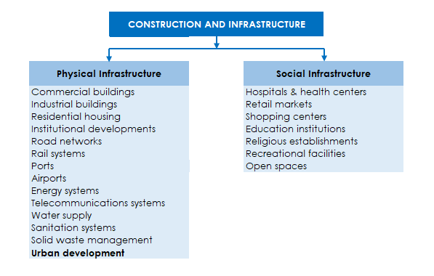
Figure 2: Summary of construction and infrastructure projects in the JKP region
Source Author (2024)

Construction and infrastructure developments are labour intensive, highly impactful socio-economically, as well as large consumers of natural resources including land, stones and blocks, asbestos, sand, ballast, murram, timber and wood products, water and energy. These activities also generate enormous wastes including waste water, dust and fumes, oils and chemical wastes, debris, waste wood, litter, plastic wastes, soil and rocks, construction demolition waste, among others.
The project took on the ‘life cycle approach/perspective’ in its analysis of the production-consumption paradigm in the sector. This entailed undertaking a value chain analysis throughout the whole life cycle of the construction and infrastructure projects in the JKP region, as illustrated in Figure 3 below. This was done through the application of life cycle thinking, which ‘expands the traditional focus on the production site and manufacturing processes and incorporates various aspects over a product’s entire life cycle from cradle to grave (i.e. from the extraction of resources, through the manufacture and use of the product, to the final processing of the disposed product).’

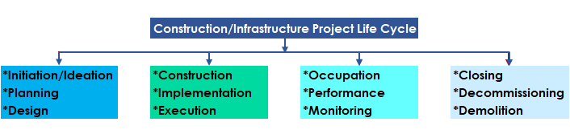
Figure 3: Construction and infrastructure project life cycle
Source: Author (2024)

Most of the construction and infrastructure activities in the JKP region are regulated by law, policy and other governance frameworks. This report highlights how enhancing global, regional, national and sub-national SCP Policy frameworks can ensure the sustainability of construction and infrastructure projects in the JKP region throughout their entire life cycle (Figure 4).
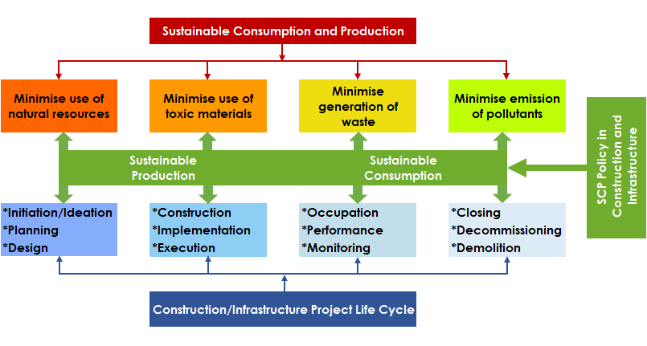
Figure 4: Conceptual Framework for ensuring SCP in construction and infrastructure projects
Source: Author (2024)

CHAPTER TWO

SITUATIONAL AND GAP ANALYSIS IN THECONSTRUCTION AND INFRASTRUCTURE SECTOR

2.1 Introduction
There is an undeniable nexus between development and the environment. Economic growth and development coupled with the concurrent expansion of construction and infrastructure projects invariably results in environmental degradation. With the push for urbanization globally and for socio-economic development, as well as regional thrusts geared towards driving African economies (including Kenya) forward into middle income status, the JKP region faces a huge risk of sacrificing its valuable environmental resources at the altar of this much desired economic advancement. It is therefore imperative to temper growth and development with environmentally sustainable practices.
This potential negative outcome of the development process should in no way discourage the three project counties from working tirelessly to meet their aspirations for growth and development, as well as to improve their economic performance. On the up-side, there are indications that there is a direct link between a city’s environmental performance and its Gross Domestic Product (GDP) per head, with wealthier cities having access to the resources needed to invest in green infrastructure.
In tandem with the wide array of possible construction and infrastructure projects identified in Chapter 1, the scope of legal and policy frameworks associated with the sector is equally broad. The research/project sampled a broad spectrum of legal and policy instruments guiding and governing the construction and infrastructure sector in Mombasa, Kwale and Kilifi counties from a global, regional, national and sub-national lens (Figure 5).
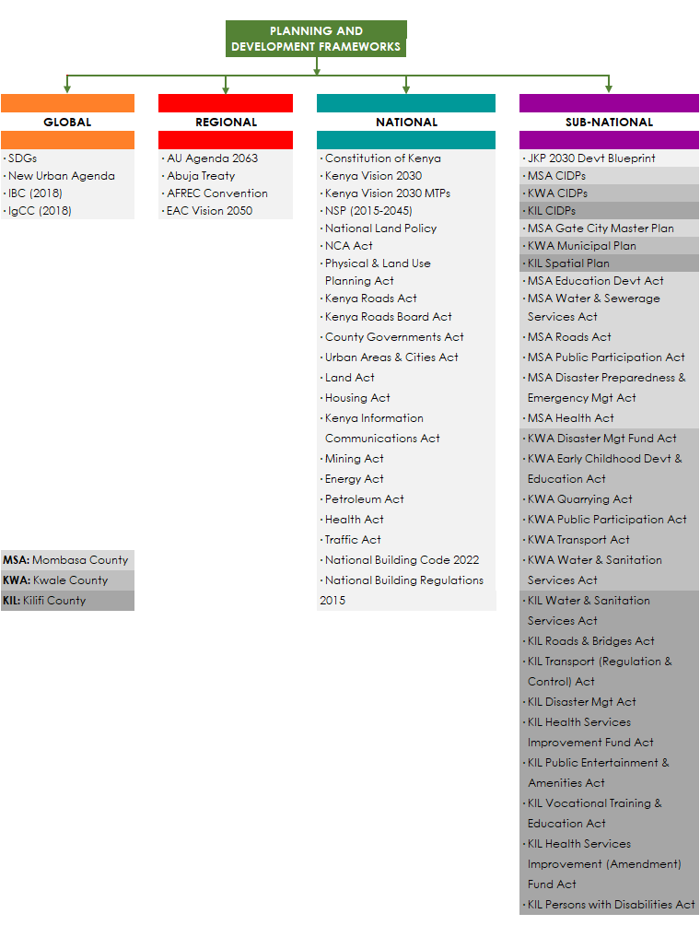
Figure 5: Summary of Planning and Development Frameworks Sampled
Source: Author (2024)

2.2 National and Regional Development Priorities
Kenya Vision 2030 is Kenya’s development blueprint spanning from 2008 to 2030 and aimed at ‘transforming Kenya into a newly industrializing middle-income country providing a high quality of life to all its citizens by the year 2030. The Vision is based on three pillars – the economic, the social and the political. It has been structured to be implemented in successive five-year Medium Term Plans (MTPs) which summarize the national projects and programmes scheduled for implementation within the given time frame, popularly referred to as “flagship” projects. A number of these flagship projects invariably fall under the construction and infrastructure sector within the three project sites. The social pillar of Vision 2030 also directs the country towards a sustainable development model defining a vision for a ‘just and cohesive society enjoying equitable social development in a clean and secure environment’. The Vision goes even further to defines flagship projects specifically geared towards the environment.
In itself a flagship project of Kenya Vision 2030, the National Spatial Plan (NSP) was created to support the implementation of strategic national projects (flagship projects) spelt out under the national development blueprint. It is a long term development Plan spanning a period of thirty (30) years, from 2015 to 2045, with provision for 10 year periodical reviews. Its aim is to ensure the achievement of organized, integrated, sustainable and balanced development within the country. The NSP conceptual framework places the three project sites of Mombasa, Diani/Ukunda (Kwale County) and Malindi (Kilifi County) in the proposed Mombasa Metropolitan Region (Map 2), creating a stimulus for intense generation of construction, infrastructure and urbanization projects in the area under study.

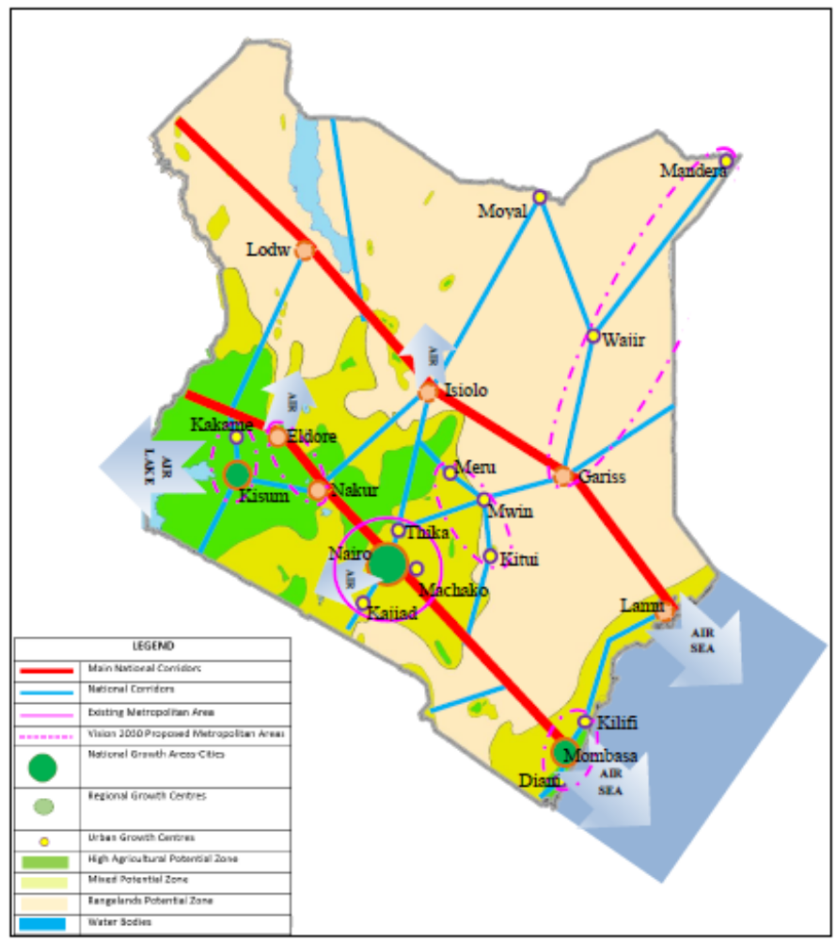
Map 2: National Spatial Plan Conceptual Framework
Source: National Spatial Plan (2015-2045)

The three project sites also fall under the jurisdiction of the Jumuiya ya Kaunti za Pwani (JKP) economic block comprising of the six (6) counties of Mombasa, Kwale, Kilifi, Tana River, Lamu and Taita Taveta, which were formerly known as the Coast Province (Map 3).
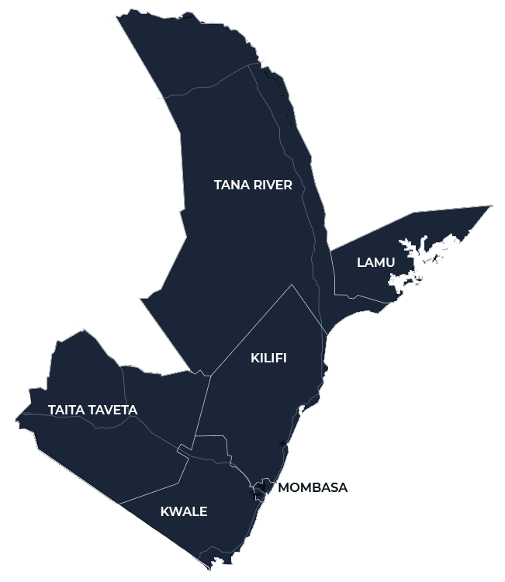
Map 3: Map of the JKP Economic Bloc
Source: https://goblue.co.ke/

A number of JKP flagship projects have been identified in the Jumuiya ya Kaunti za Pwani 2030 Development Blueprint to drive the region’s socio-economic growth and catapult the region into middle economy status. These projects have been categorised under three pillars - the Jumuiya Economic Pillar, the Jumuiya Social Pillar and the Jumuiya Foundation and Enablers Pillar.
Construction and Infrastructure development projects have been identified within all three pillars, cutting across seven out of ten sectors (Agribusiness, Food and Nutrition Security, Trade and Industries, Blue Economy, Urbanisation, Health and Education, Land Resource Development, and Infrastructure) as illustrated in Table 1 below.
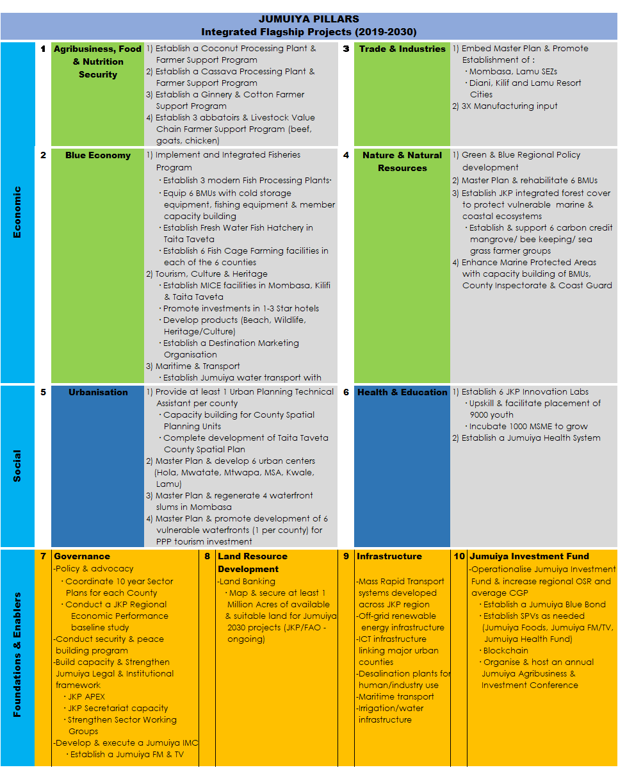
Table 1: JKP Flagship Projects (2019-2030)
Source: Adapted from JKP 2030 Development Footprint

2.3 Overview of the Selected Project Sites

2.3.1 Mombasa County
Mombasa County is divided into four physically separate areas by inlets of the sea. These are Mombasa Island (renamed Mvita constituency), Changamwe, Likoni, and Kisauni (Map 4). The island is linked to the mainland west by roads at two points, Makupa and Kipevu Causeways. Mombasa island is the business hub of Mombasa county. The County has one international airport, the Moi International Airport in Changamwe sub-county. The airport is the second largest airport in Kenya and is used by both domestic and international flights.
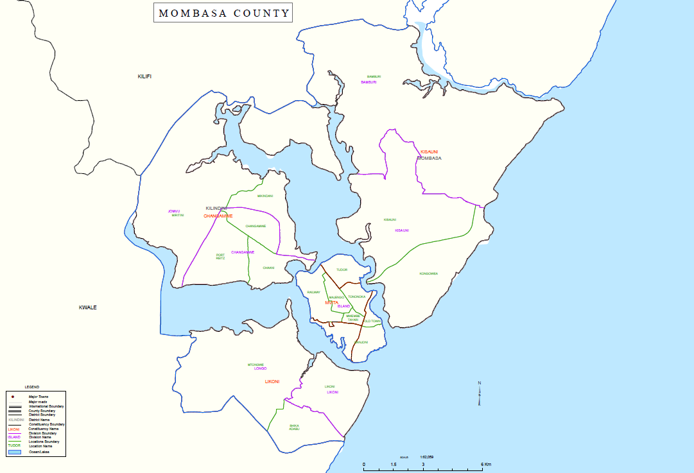
Map 4: Administrative Units in Mombasa County
Source: Mombasa CIDP (2018-2022)
The main residential areas are to be found north and south of the mainland. Majority of the structures both commercial and residential are constructed using stones. The main roofing materials are corrugated iron sheets or roofing tiles. Nevertheless, there are mud walled houses found in the slum areas. In relation to housing there is the proposed construction of affordable housing in the following areas: Buxton, Mzizima, Likoni, Changamwe, Khadija, and Miritini estates. The projects have not begun.
Mombasa County’s development priorities have been set out in its County Legislation (Acts), its County Integrated Development Plans (CIDPs), as well as in the Mombasa Gate City Master Plan (2017) developed with the support of the Japan International Cooperation Agency (JICA).
The Mombasa City Gate Master Plan gives guidance and direction in the achievement of the development vision for Mombasa County until 2040, with the sectors of focus identified as Transport, Urban Infrastructure (water supply, sewerage and drainage, solid waste management, power supply and telecommunications), Social and Public Facility (housing, education and health), Tourism and Urban Management. The priority projects identified under the Master Plan have been summarized in Table 2 below.
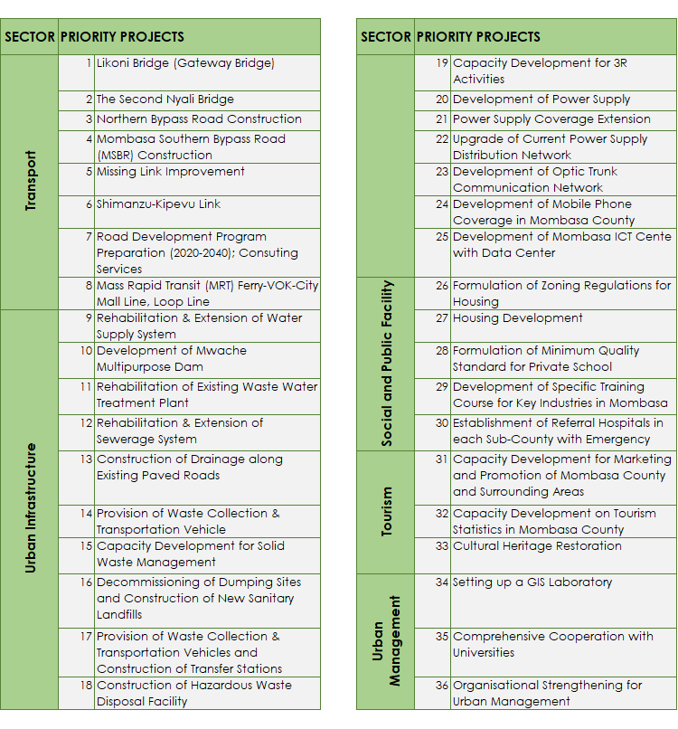
Table 2: Mombasa County Priority Projects by sector
Source: Adapted from The Mombasa City Gate Master Plan (2017)

Below is a summary of the other main construction and infrastructure projects identified for implementation within Mombasa County as outlined in its most recent CIDPs (Table 3).
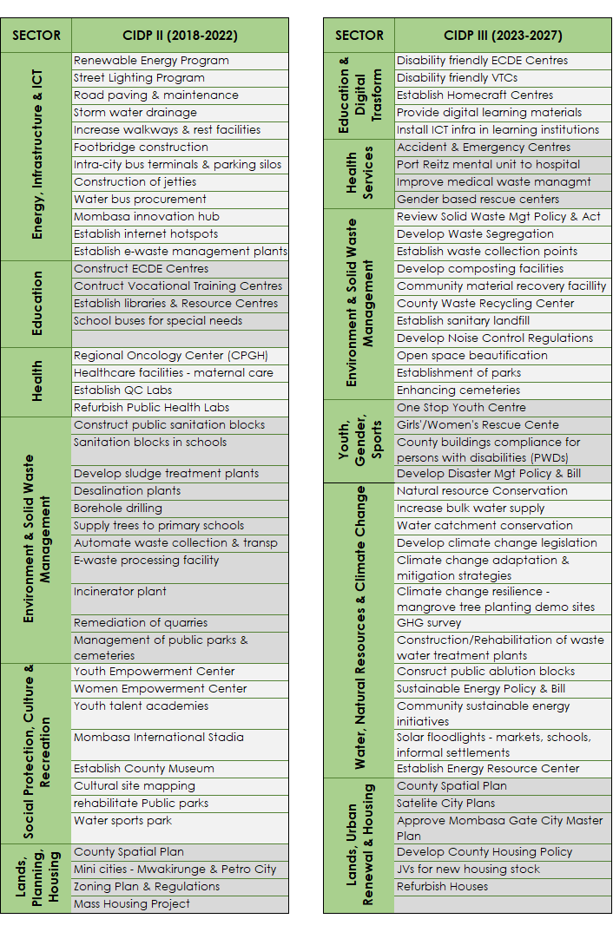
Table 3: Mombasa County CIDP Priority Areas
Source: Author (2024)
The new Kipevu Oil Terminal at the Port of Mombasa is constructed opposite the second container terminal at the port of Mombasa near Dongo Kundu. Phase one of the project is complete. The project consists of one offshore island terminal with four berths, one work boat wharf and five sub-sea pipelines. and phase II of the second container terminal at the Port of Mombasa. The second container terminal project is also complete and helps to increase the number of containers the port can handle.
The Likoni floating bridge is complete. The bridge complements the ferry services by providing commuters access through the Likoni Channel. According to plan, the Likoni Floating Bridge will be dismantled for good in 2025, once the proposed Mombasa Gate Bridge is completed.
A modern cruise ship terminal at the Port of Mombasa has been constructed and is in use. Dongo Kundu bypass is being undertaken in two phases. The entire project helps in connecting Mombasa Mainland West to Mombasa Mainland South, without entering Mombasa Island. It will ease traffic pressure at the Likoni ferry. Phase one of the project is complete. It is from Mombasa Port’s second container terminal and joins the Mombasa-Nairobi highway at Bonje, near Mazeras. The second phase, consists of an interchange at the Likoni-Lunga Lunga highway and erection of two bridges: at Mwache and Mteza. This phase is also known as the Mombasa – Mtwapa – Kilifi dual carriageway project. This phase is ongoing. Ultimately the Dongo Kundu project will help in easing transportation between Mombasa and Kwale, and enhance Mombasa port’s efficiency.
The Mombasa-Mariakani road which encompasses the Makupa bridge also incorporates a pedestrian walk. The project is complete. The road connects the Tudor and Port Reitz creeks and does away with the Makupa causeway. It includes a three-deckers inter-change at Changamwe. The road provides a link between Kenya’s mainland and the island of Mombasa. Moreover, it eases movement from the Moi International Airport into the mainland.
While the major roads are in fair condition, access roads within the residential and industrial areas are generally in a poor state. The situation is worsened by the poor storm drainage systems most of which are in a dilapidated condition. The roads are maintained by the national government through Kenya Rural Roads Authority (KeRRA) and overseen by Sub-County Road Committees, Kenya Urban Roads Authority (KURA) and the Kenya National Highways Authority (KeNHA) and the private sector.

2.3.2 Kwale County
Kwale county is located in Kenya’s South Coast, and borders Tanzania to the south, Taita Taveta county to the west, Kilifi county to the North, and Mombasa county to the north-east. It is divided into four sub-counties (Kinango, Matuga, Msambweni and Lunga-Lunga), which are further sub-divided into various wards. Project site 2 (Ukunda/Diani) is located in Msambweni sub-county, which falls within Kwale Municipality as illustrated in Map 5 below.
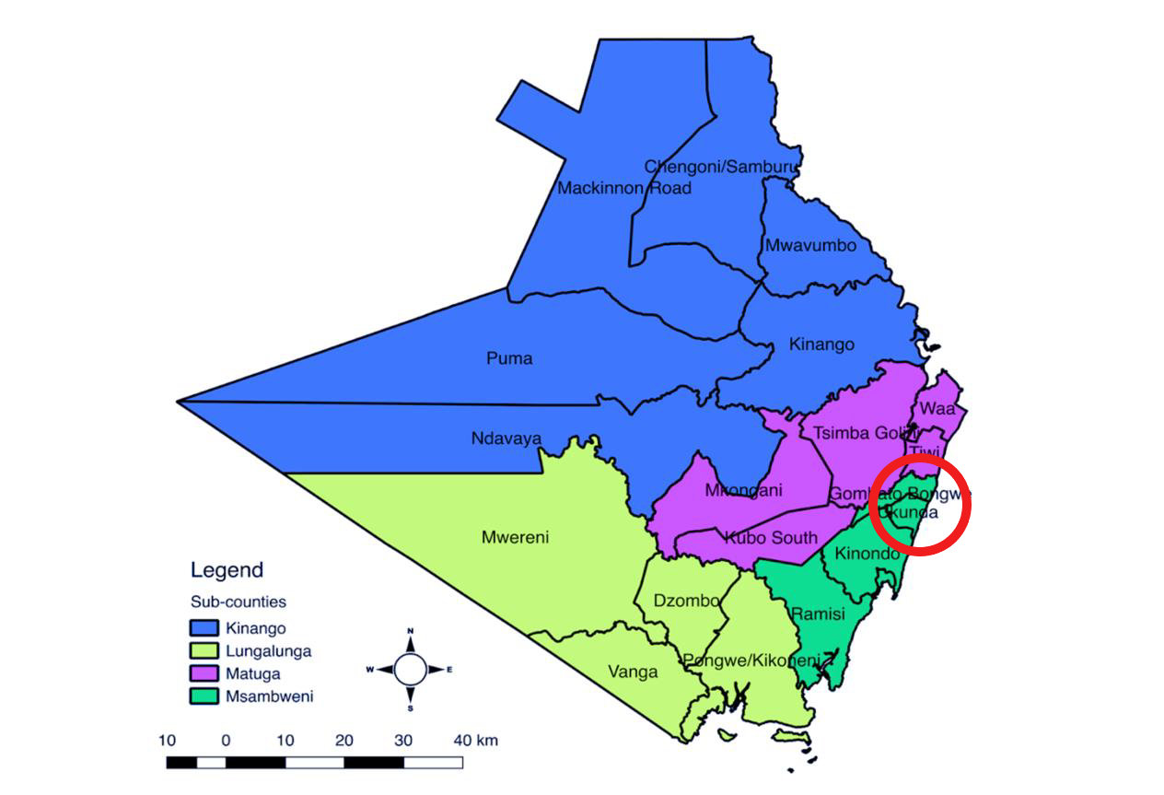
Map 5: Administrative Units in Kwale County
Source: Adapted from Kwale CIDP (2018-2022)

Kwale County’s development priorities have been set out in its County Legislation (Acts) and County Integrated Development Plans (CIDPs). In addition, some of the priority construction and infrastructure projects identified under The Kwale Municipal Plan have been summarised in below:
- Completion of Dongo Kundu Bypass to connect Mombasa and Kwale
- Tarmacking of Kinango-Kwale Road
- Improving local circulation
The County's physical infrastructure has, however, remained underdeveloped. Kwale County has a total of 2,028 km of classified roads of which 212.5 km are bitumen surface (paved surface), 425.2 km is graveled and 1,695.5 km of earth surface roads/rural access roads. There are 4 km of railway line and four (4) airstrips at Ukunda/Diani, Shimba Hills National Reserve, Msambweni and Kinango although only Ukunda/Diani is operational. There is a small fishing port at Shimoni (Figure 6) which is mostly used for water transport by boats controlled by the Kenya Wildlife Service (Kwale CIDP 2018-2022). With the change over to the new government, after the gubernatorial elections in August 2022, there is a need to have a review of progress that has since occurred.
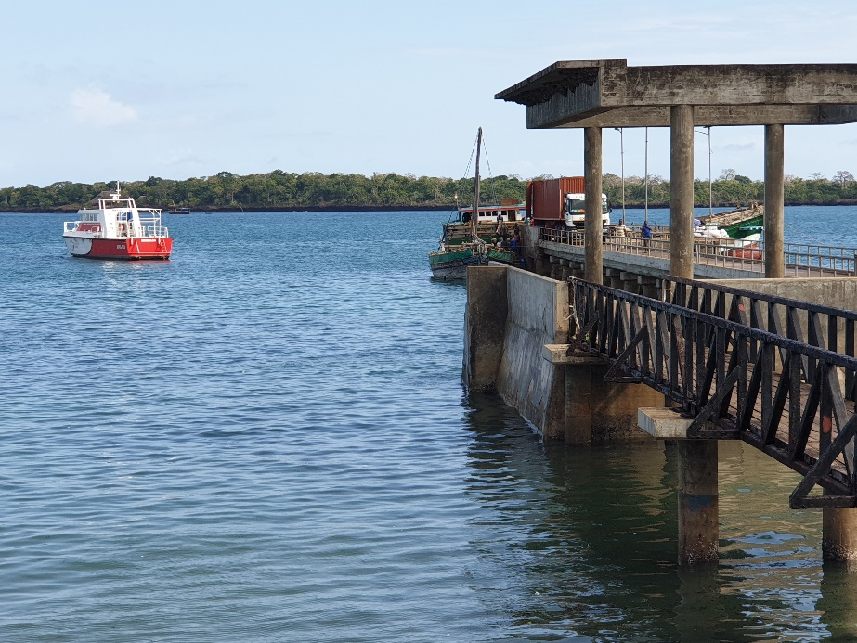
Figure 6: Small jetty at Shimoni Fishing Port in Kwale County
Source: Author (2021)

Much of the housing developments in the county are traditional in nature. They consist primarily of coconut tree leaves (makuti) thatched dwellings. This is interspersed with corrugated iron sheet roofing. It was also observed that the construction materials for the walls of these dwellings is mud, and wood, mud and cement and for some stones. However, the majority of the stone dwellings are found in the urban areas.
The current, on-going infrastructure developments in the area include the following:
- The Dongo Kundu Road project which links with the county of Mombasa will improve the movement of goods and people between the two counties.
- Diani Resource City as part of an urbanization project. This is a Kenya Vision 2030 flagship project. The resort will be family oriented and primarily targeting high-income tourists, both local and international. Its construction will improve tourism, infrastructure development and development of other amenities.
- The construction of the Shimoni Fishing Port by Kenya Ports Authority (KPA) is underway. This flagship project aims to improve fish production, processing and value addition for the local and export markets. The facility will house a market hall, cannery, storage facility and a wastewater treatment facility.
- The Samburu-Kinango-Kwale road has partially been upgraded to bitumen standards. The road connects Samburu with the Mombasa-Lunga-Lunga highway through Kwale- Kombani. It will ease congestion at the Likoni ferry channel as well as opening up Kwale to more business and developments. For example, the Devki Steel factory that was recently opened in Kwale. However, a 29 km stretch of the road from Kinango to Kwale town has stalled due to lack of funding. Moreover, it is documented that there is lack of maintenance of the road.
- The development of the Tsunza Resort City aims to provide economic development and open up the area for more trade and development.
- Other key infrastructure projects include upgrading the airstrip in Shimba Hills Reserve, provision of street lighting in Kwale town, enhancing water provision in the municipality (water treatment plants, water distribution project, storm water management, sewerage system and wastewater treatment plant), construction of more health facilities in the Municipality, the construction and establishment of various educational institutions (ECD centers, primary schools, secondary schools and tertiary institutions), promoting access to social services, recreational and sports facilities, and the preservation of environmentally sensitive areas.

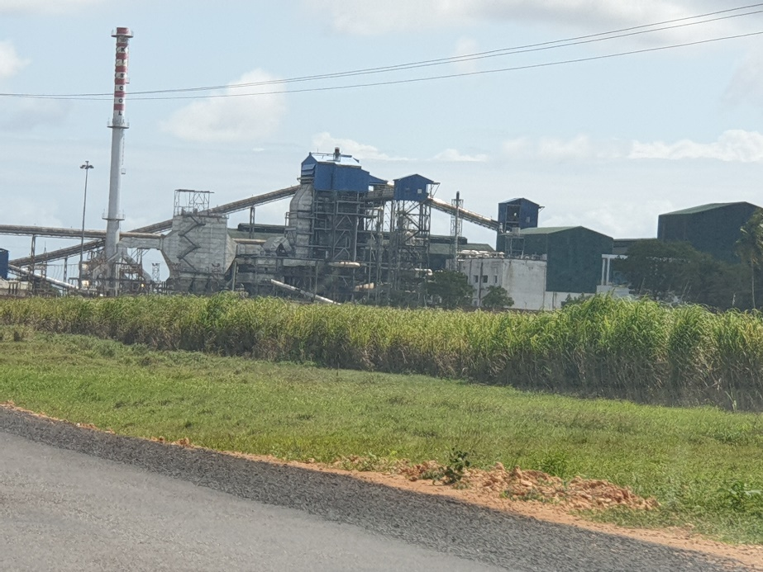
Figure 7: Ramisi Sugar Mill in Kwale County?
Source: Author (2021)

2.3.3 Kilifi County
Kilifi County has seven (7) sub-counties, namely Kilifi North, Kilifi South, Malindi, Kaloleni, Magarini, Ganze and Rabai . Project site 3 (Malindi) is located in Malindi sub-county as illustrated in Map 6 below.
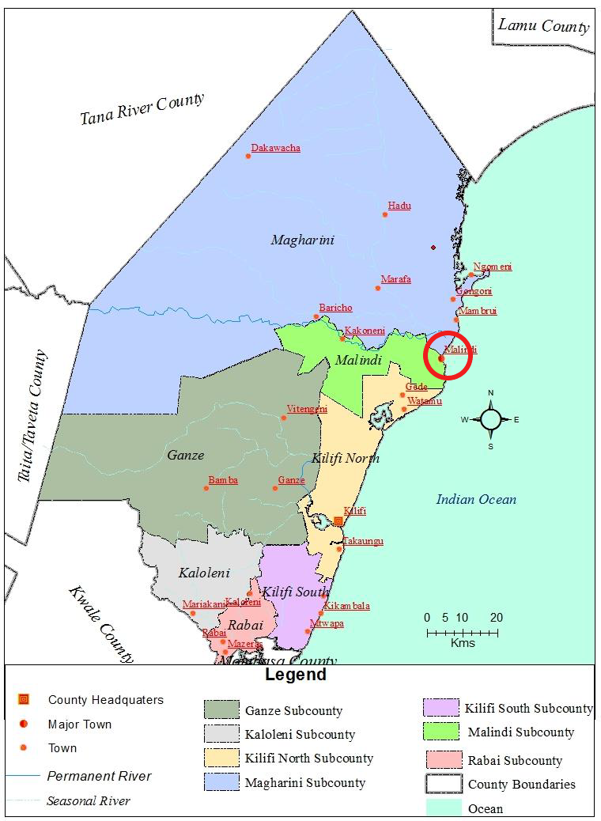
Map 6: Administrative Units in Kilifi County
Adapted from Kilifi County CIDP 2018-2022
Kilifi’s County’s development priorities have been set out in its County legislation (Acts) County Integrated Development Plans (CIDPs), as well as the Kilifi County Spatial Plan (2021-2030).
A 40 MW solar plant, located in Langobaya, is complete and has been connected to the national grid. This project boosts the production of green energy. Upgrade of the Barclays Mtangani road to bitumen standard. the road connects from the Mombasa Lamu highway A7 to Paradise hotel. The road will improve accessibility as well as the issue of perennial flooding and stagnation of water in the area.
The Kilifi county government’s infrastructure projects have focused on upgrading/rehabilitation of internal roads, the construction of bridges With regard to residential infrastructure the county government is focused on achieving the following: developing a housing estates master plan and development guidelines for all the county estates; undertaking estate management and maintenance;- the upgrading of informal settlements and settlement schemes; upgrading of access roads by upgrading them to bitumen standards or making them murram standard; and purchasing land for housing to development.

2.4 Review of Relevant International and National SCP Relevant Legal, Policy and Other Governance Frameworks

2.4.1 International Legal Framework
New Urban Agenda, 2016
In 2016, countries came together under the auspices of the UN-Habitat and adopted the New Urban Agenda. The Agenda captures sustainable consumption and production trends in construction towards sustainable urbanization practices. The State parties commit to develop and adopt sustainable, renewable and affordable energy and energy-efficient buildings and construction modes. Under the Agenda, the parties commit to making sustainable use of natural resources and focusing on the resource efficiency of raw and construction materials such as concrete, metals, wood, minerals and land. In developing sustainable and resilient buildings parties commit to enhance and prioritise the use of local, non-toxic and recycled materials and lead-additive-free paints and coatings as SCP approaches in the construction industry.
International Building Code, 2018
The International Building Code (IBC) is a model code that provides minimum requirements to safeguard the health, safety and general welfare of occupants in building structures.
International Green Construction Code, 2018 (IgCC)
The code is designed to propose provisions that promote safe and sustainable construction in an integrated fashion with the (International Construction Code) ICC Family of Codes. The IgCC provides minimum requirements to safeguard the environment, public health and safety to minimize the negative impacts of the built environment to natural resources. The Code addresses among others water efficiency, energy efficiency, planting trees on site and site waste management. Regulation 5.3.8.1 recommends that land clearing debris, rock and soil should be diverted from disposal by compositing, recycling or reusing. On wastewater management the Code under Regulation 6.3.6 prescribes reusing water including the use of reverse osmosis for water treatment.
Another relevant global framework that informed this study is the 2030 Agenda for Sustainable Development (SDGs), which at SDG 12 provides the anchorage for sustainable consumption and production.

2.4.2 Regional Legal Framework
East African Community Vision 2050
The Vision 2050 lays out a broad East Africa’s perspective in which the region optimizes the utility of its resources to the productivity gap through regional integration. The common shared vision outlines the major infrastructure development programs within the EAC community. Notably, one of the sites, Mombasa, is a major transport corridor in the EAC. In addition, the EAC intends to harmonize the policy, legal and regulatory frameworks to create an enabling environment that will harness economies of scale through regional integration. Notably, in the preambular text the Vision is aimed at ensuring assimilation of the SDGs within the Community. However, despite the emphasis on construction and infrastructure as a key integration pillar the Vision falls short of mentioning sustainable construction and infrastructure practices as a critical element of building resilient cities.
Other relevant regional frameworks that informed this study include:
- AU Agenda 2063: The Africa We Want
- Treaty Establishing the African Economic Community (Abuja Treaty)
- Convention of the African Energy Commission (AFREC)

2.4.3 National Legal and Policy Frameworks
The Constitution of Kenya, 2010
The Constitution of Kenya has provisions for sustainable land use planning. Article 60 provides that land in Kenya is to be held, used and managed in an equitable, efficient, productive and sustainable manner, including through sustainable and productive management of land resources, as well as sound conservation and protection of ecologically sensitive areas. Moreover, the Constitution classifies land in Kenya as public, community or private. All roads and thoroughfares provided for by an Act of Parliament are defined as part of public land. Therefore all roads and public accesses and spaces across the country, including in the sites and cities of concern herein, are part of public land. In general, public land under certain categories shall vest and be held by a county government in trust for the people resident in the county, or in national government in trust for the people of Kenya, and shall in both cases be administered on their behalf by the National Land Commission (NLC). One of the key functions of the NLC, which is one of the constitutional Commissions established under the Constitution, is “to manage public land on behalf of the national and county governments”. It is also mandated “to recommend a national land policy to the national government”.
Under the Constitution, private land consists of land held by any person under any freehold tenure; land held by any person under leasehold tenure; and any land declared private land under an Act of Parliament.
In terms of regulation of land use and property, the State may regulate the use of any land, or any interest in or right over land, in the interest of defence, public safety, public order, public morality, public health or land use planning. Thus, the State has a mandate to regulate land use, whether in public, community or private land. This has a direct bearing on construction and infrastructure developments in urban, peri-urban and rural areas.
However, while the Constitution provides a broad framework for sustainable utilization of resources including land, it does not directly address sustainable consumption and production. Ultimately, though, it is supportive of SCP and provides a good basis upon which specific legislative, regulatory and policy frameworks can further anchor SCP, including in the construction and infrastructure sector.
National Construction Authority Act, 2011
The National Construction Authority (NCA) is the government Agency charged with the responsibility for accreditation of construction firms, certification of construction workers, registration of construction projects and the training and certification of construction workers, in accordance with the National Construction Authority Act 2011.
Physical and Land Use Planning Act, No. 13 of 2019
The Act provides for organizing the physical infrastructure in an orderly and effective manner that encompasses deliberate spatial plans that achieve the optimum level of land utilization in a sustainable manner. In fulfilling this overarching mandate, the Act prescribes the incorporation of sustainable consumption and production practices. The Act is guided by the need to plan development activities in a manner that integrates economic, social and environmental needs of present and future generations. In planning for the use of land, the Act prescribes the integration of new technologies and environmentally friendly approaches to achieve sustainable development and efficient use of natural resources. The Act also provides for the development of a National Land Use Development Plan for among other purposes the conservation, protection and improvement of the environment in development of land.
Kenya Roads Act, No 2 of 2007
The Act establishes the Kenya National Highways Authority(KeNHA), a government agency that is responsible for among other mandates to construct, maintain and rehabilitate national roads. The Act also establishes the Kenya Rural Roads Authority (KERRA) with a mandate similar to that of KeNHA with regards to all rural roads. In discharging this mandate, the Agencies are required to ensure that the quality of roads is in accordance with the standards recommended by the Cabinet Secretary. Finally, the Kenya Urban Roads Authority (KURA) is established with the responsibility for the management, development, rehabilitation and maintenance of all public roads in the cities and municipalities in Kenya, except where those are national roads. Notably, the Act makes no reference to sustainable consumption and production practices in the construction and maintenance of the roads.
Climate Change Act, 2016
The Act reaffirms the government commitment to promote low carbon technologies and reduce carbon emissions through uptake of technologies that support low carbon and climate resilient development.
County Government Act, 2012
The Act requires that a county government shall plan for the county and no public funds shall be appropriated without a planning framework. It also states that the county planning framework shall integrate economic, physical, social, environmental and spatial planning. In addition to an integrated county development plan, each county is expected to have the following:
i) County Sectoral Plan (for the county departments and other county entities);
ii) County Spatial Plan; and
iii) City and Urban Areas Plans.

In this regard, the Kilifi County spatial plan has mapped out action area plans and areas in construction and infrastructure. This include, road projects including Malindi-Tsavo road C103, Adu-LAPSET link road, Watamu-Malindi road, Gede-Kakuyuni, construction of two major bridges namely; across Galana river and Sabaki at Baricho and Shakahola and construction of an international airport at Langobaya in Jilore ward. The plan also espouses plans to upgrade existing building materials industries in Mazeras and Jaribuni.
National Land Use Policy, 2017
The Policy addresses the use of locally available materials for purposes of construction. The Policy notes that the use of locally available material poses a danger to the environment. To address the problem, the policy recommends that the government should come up with guidelines and standards for the utilization of natural resources in the construction industry. The policy also recommends the promotion and application of environmentally friendly technologies in construction.
National Building Code, 2015
The Code has antecedents of sustainable consumption and production. Rule 54 of the Code provides that where there is excessive rubble, debris, or combustible waste on a construction site the approving authority may order the owner of the premises to remove the waste within a specified period. Rule 161 of the Code provides that a designer designing a building may conform with the sustainable design strategies derived from independent green building organization certificates. The Code also recommends the installation of renewable energy under Rule 162. Rule 167 provides that a building should conform with sustainable building designs that minimizes the use of non-renewable resources. In the event of demolitions, the Code recommends that efforts should be made to reduce wastage and recycle salvaged materials. The Code also recommends the use of other SCP practices in construction such as: use of natural ventilation and cooling systems, conserving the existing trees and topography in a project site to up to 2.5%, use of locally available building materials that are sustainably harvested, use of water efficient appliances, use of environmentally friendly toilets and sewerage systems and use of sustainable design innovations. The First Schedule recommends that waste water from construction sites should be recycled and used for irrigation and outdoor cleaning.
Green Economy Strategy and Implementation Plan Kenya, 2016-2030
The policy provides a pathway for Kenya’s low carbon, resource efficient, equitable and a socially transformative approach. Under broad Objective 1.4, the strategy addresses sustainable designs, construction and maintenance of buildings. To achieve the objective, the Plan lays out strategies including; to ensure that 75% of new and renovated public and private large scale buildings are green by 2030, capacity building for professionals in the construction sector on integrated green technologies on design and construction and to develop green certification standards.
Other relevant National frameworks that informed this study include:
- Kenya Vision 2030
- Kenya Vision 2030 Medium Term Plans
- The Kenya National Spatial Plan (2015-2045)
- National Land Policy
- Urban Areas and Cities Act (Cap 275)
- Land Act (Cap 280)
- Housing Act (Cap 117)
- Irrigation Act (Cap 347)
- Kenya Information and Communications Act (Cap 411A)
- Mining Act (Cap 306)
- Energy Act (Cap 314)
- Petroleum Act (Cap 308)
- Health Act (Cap 241)
- Traffic Act (Cap 403)

2.4.4 Sub-National Legal Framework

a. Mombasa County
Below is a list of the County legislation that has been developed to guide and regulate the Construction and Infrastructure Sector in Mombasa County. They affect developments in education, water and sewerage, roads, disaster preparedness and health, among others:
- Mombasa County Education Development Act, No 11 of 2014
- Mombasa County Water and Sewerage Services Act, No 2 of 2016
- Mombasa County Roads Act, No 8 of 2016
- Mombasa County Public Participation Act, No 6 of 2017
- Mombasa County Disaster Preparedness and Emergency Management Act, No 8 of 2017
- Mombasa County Health Act, No 6 of 2018
The Mombasa Public Participation Act is pegged on the Constitution, specifically chapter 11, the general principles on public participation and part VIII of the County Governments Act. Generally, it provides a legal framework for facilitating public participation in the County Government processes and decision making as relates to issues affecting them. These include construction and infrastructure developments. Overall encouraging public participation, the Act seeks to:
- promote participatory democracy;
- transparency and accountability in decision making;
- community empowerment and support;
- promote partnership and collaboration in public processes;
- enhance public awareness and understanding of government processes;
- reduce conflicts related to public or government decisions; and
- enhance community ownership of public decisions

b. Kwale County
Below is a list of the County legislation that has been developed to guide and regulate the Construction and Infrastructure Sector in Kwale County:
- Kwale County Disaster Management Fund Act, No 7 of 2016
- Kwale County Early Childhood Development and Education Act, No 9 of 2016
- Kwale County Quarrying Act, No 11 of 2016
- Kwale County Public Participation Act, No 12 of 2016
- Kwale County Transport Act, No 3 of 2017
- Kwale County Water and Sanitation Services Act, No 2 of 2020
The enactment of the Public Participation Act stems from the requirement in the Constitution that public participation is a guiding principle in governance of the country. The Kwale legislation specifically indicates that the county government activities will be guided by:
- the public to be affected by a decision shall have a right to be consulted and involved in the decision making process;
- public contributions shall be taken into consideration when making the decisions;
- promotion of sustainable decisions by recognizing and communicating the needs and interests of the public;
- support the involvement of the public potentially affected by or interested in a decision;
- the public have equitable access to information for their meaningful participation;
- communication to the public on how their input affected the decision;
- adherence to the national values and principles of governance set out under Article 10 of the Constitution;
- adherence to the values and principles of public service set out by Article 232 of the Constitution;
The statute also provides guidelines on how the participation shall be undertaken. Likewise, there is a guiding policy in place. The statute has made a good attempt at laying the foundation to facilitate public participation in the county. It would be vital in efforts to advance the SCP agenda in the county as the success of sustainable consumption and production initiatives would have to include public participation and buy-in. Nevertheless, the main challenge relates to its effective implementation.
Kwale County has a Monitoring and Evaluation Policy. Unlike the Public Finance Management Act, 2012 (PFM) at the national level, the county of Kwale monitoring and evaluation policy has attempted to cover a broad base in terms of the applicability of monitoring and evaluation (M&E). The PFM Act focuses more on monitoring and evaluating financial performance. It does not provide guidance on the M&E of programmes and projects yet it is necessary to ascertain whether a project or programme is achieving the desired results or not. Nevertheless, to address this gap, the Kwale M&E Policy has worked towards sealing this gap by providing for a broad definition in relation to what activities/events would require M&E. Consequently, even the non-budgetary aspects of infrastructure development are subjected to M&E, which would be an important tool in ensuring the ultimate success of SCP initiatives.

c. Kilifi County
Below is a list of the County legislation that has been developed to guide and regulate the Construction and Infrastructure Sector in Kilifi County:
- Kilifi County Water and Sanitation Services Act, No 6 of 2015
- Kilifi County Roads and Bridges Act, No 7 of 2015
- Kilifi County Transport (Regulation and Control) Act, No 9 of 2016
- Kilifi County Rating Act, No 10 of 2016
- Kilifi County Disaster Management Act, No 15 of 2016
- Kilifi County Health Services Improvement Fund, Act No 16 of 2016
- Kilifi County Public Entertainment and Amenities Act, No 21 of 2016
- Kilifi County Vocational Training and Education Act, No 18 of 2017
- Kilifi County Health Services Improvement Fund Amendment Act, No 1 of 2022
- Kilifi County Persons with Disabilities Act, No 3 of 2022

CHAPTER THREE

KEY FINDINGS

3.1 Analysis of Desktop Reviews
The legal and policy framework governing the construction and infrastructure sector is robust at the global, regional and national level in matters concerning identification of development priorities. Moreover, Mombasa, Kwale and Kilifi Counties continue to actively define and refine their local development priorities through their CIDPs, the Mombasa Gate City Master Plan, the Kwale Municipal Plan (2023-2032) and the Kilifi County Spatial Plan (2021-2030) respectively.
The need for development priorities to be tempered/regulated by SCP governance frameworks cannot be underscored. To this end, this research sought to scrutinise existing global, regional, national and sub-national SCP Frameworks against the backdrop of the different elements of SCP, while also taking into consideration their application throughout the life cycle of construction and infrastructure projects (from cradle to grave).
Having recognized that local environmental challenges have trans-boundary effects, world leaders have banded together since 1972, and held a series of global engagements which have set the global agenda adopted by many nations in the effort to bridge the gap between development and environment (Figure 8). These engagements have laid the foundation for the evolution of the concept of sustainable development.
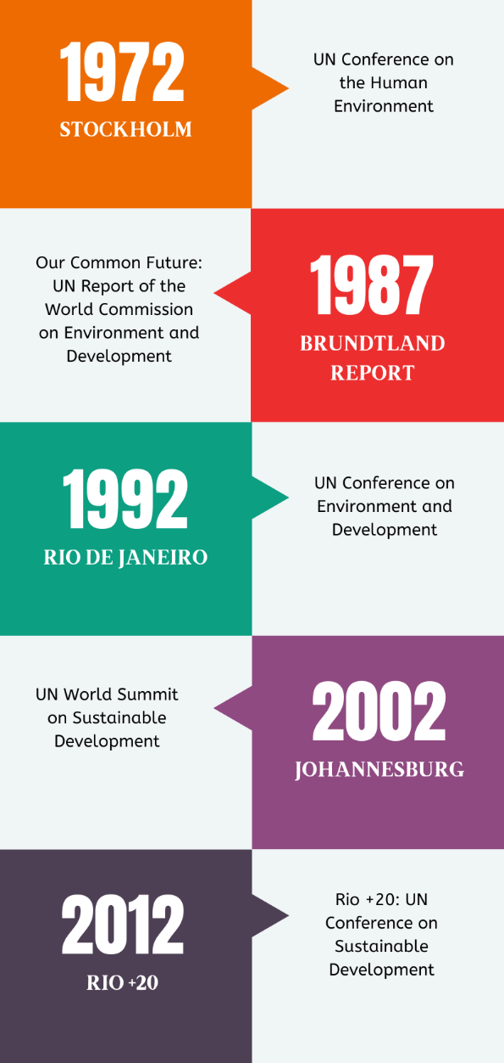
Figure 8: Milestones in International Environmental Law
Source: Author (2024)

According to a 2014 report by the Intergovernmental Panel on Climate Change (IPCC) the building and construction sector accounts for 30% of global energy use and a commensurate level of GHG emissions. Similarly, a 2022 working group report models different global scenarios for existing buildings and buildings yet to be built and projects a net zero GHG emissions in 2050 if policy packages, which combine ambitious sufficiency, efficiency, and eco-friendly measures, are effectively implemented. The UN Habitat proposes interventions to make construction more environmentally friendly. In a 2015 report the UN Habitat proposes interventions inter alia: the use of energy efficient sources, use of recyclable material, waste management, use of renewable energy and resilient and low carbon infrastructure.
The Kenya Building Research Centre (KBRC) has conducted research to build the knowledge base on a sustainable built environment in Kenya. In 2019 the Centre published reports that mapped out the building materials in the coastal region. In Kilifi County, the report reveals that the common building materials included; ballast, washed sand, palm trees (makuti) , casuarina trees, brick, mazera stone, coral blocks, hard core stones and to a minimal extent interlocking blocks. The report also notes that traditional building materials such as makuti and coral stones are being replaced by modern materials such as precast products and bricks. The report also addresses and encourages the use of alternative technologies due to the threat of depletion of locally available natural materials. A similar study in Kwale County reveals the common building materials include; pit sand, river sand, white sand, coral stone, makuti, hard core and ballast. In Mombasa County, the commonly used material for building include:balcony balustrades , bricks, building stones, cabro, cement, chips blocks, cinder blocks, coral reef stones, glass, limestone, makuti, metal windows, terrazzo chips and doors. In Mombasa specifically, the report observes that the traditional and modern building materials used within the region have shaped the local architecture of the area and the unique identity for the area.
Generally, the reports in the three counties observe that, firstly, the use of locally available materials for construction is common in the three counties. Secondly, the materials are made available through large industries, small cottage industries, fabricating, sand harvesting, and quarrying. Thirdly, the construction materials are produced for in-county use and use by other counties (including inter-county export in the counties under study).Fourthly, building materials in the coastal region have been changing over time with a slow paced replacement of traditional building materials such as makuti and coral stones with modern technologies. Lastly, the three reports call for the use of modern technologies and sustainable building designs due to the threat of depletion of natural resources posed by the use of traditional building materials.
While progress has been noted in the generation of SCP policy and legal instruments for the construction and infrastructure sector, with frameworks on the emission of pollutants taking the lead, a lot of work still needs to be done to accelerate the generation of other SCP frameworks, particularly in the area tackling the minimisation of the use of toxic materials. A summary of the analysis of existing SCP frameworks addressing the different elements of SCP has been presented in Figures 9-12 below.
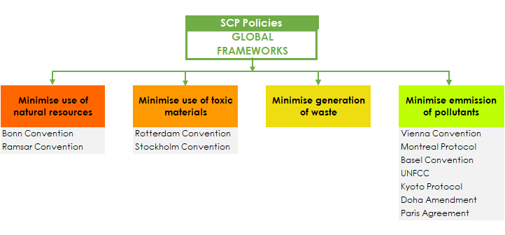
Figure 9: Analysis of sampled Global Frameworks addressing different elements of SCP
Source: Author (2024)

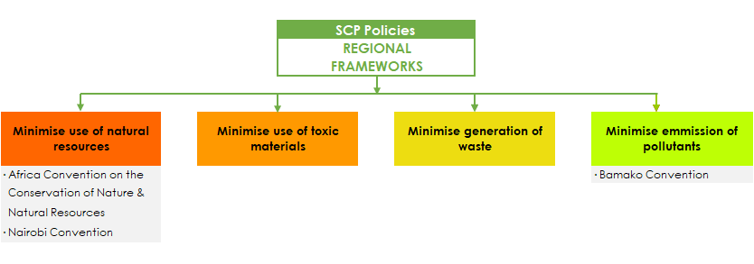
Figure 10: Analysis of sampled Regional Frameworks addressing different elements of SCP
Source: Author (2024)

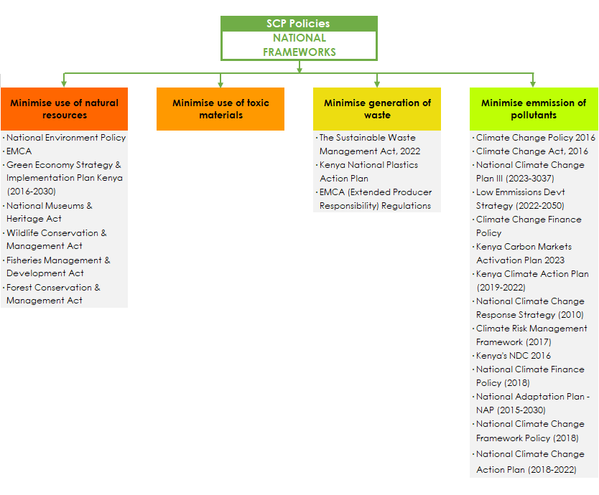
Figure 11: Analysis of sampled National Frameworks addressing different elements of SCP
Source: Author (2024)
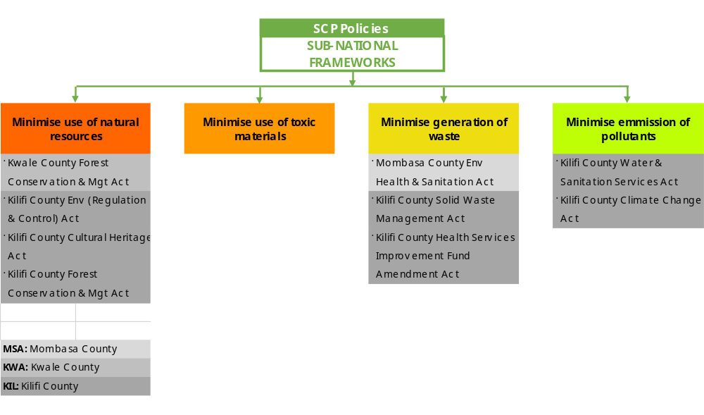
Figure 12: Analysis of sampled Sub-National Frameworks addressing different elements of SCP
Source: Author (2024)

In general the analysis of desktop reviews identified the following gaps in terms of the available legislations and policies:
- The policies and legislations do not ‘speak to each other’ that is, there is no integration;
- In some cases, policies relevant to the implementation of legislation have not been developed;
- There are gaps in terms of not having legislations that have provisions geared towards ensuring the development of sustainable/green infrastructure;
- Lack of awareness of the legislations and policies that are already in in force;
- Lack of or poor implementation;
- Weak legal and regulatory framework for SCP;
- Lack of policy documents to guide most of the county functions;
- Lack of a projects implementation framework;
- Weak link between the CIDP, ADPs and budgets;
- SCP frameworks identified do not take into account the Life Cycle Approach/Perspective in decision-making and development processes

3.2 Analysis of field based responses
The field work research is based on findings from the different stakeholders and players in the construction sector within the three sites. The findings are based on site visits and Focus Group Discussions(FGDs) with National Government offices and County governments.
In general, we observed that in all sites of concern, construction works, especially of commercial buildings and residential units were many and diverse. In Mombasa City, there were numerous high rise buildings containing commercial premises and residential premises. It would appear that sooner than later Mombasa city’s skyline will be full of skyscrapers. To a lesser extent, this is also the case in Malindi and Ukunda/Diani. Equally noticeable were expanding infrastructure facilities, including roads and bridges, as well as recreational facilities including public parks.
The constructions typically used conventional building materials, including stones, sand, concrete, cement, wood and timber products, water, and electricity. These were noticeable both from the active construction sites and the timber, wood, sand and stone and hardware yards in the cities and surrounding areas. We also observed stone quarries which provide sand stone products. There were also several yards holding construction waste and used materials that were for resale. In general, though, it appears that construction waste was not as ubiquitous as normal consumption solid waste including food waste. In most cases the scaffolding and formwork materials were wood and timber, as well as fabricated metal. As usual, construction and infrastructure developments consume lots of water and electricity, in turn producing waste water, chemical wastes and fumes.
In general, most of the housing and buildings construction works were private sector dominated, while infrastructure developments were contracted public works.
The team met and interviewed several government officials representing national and county government departments and agencies in the cities of concern. A summary of some of the responses is provided below.

3.2.1 Kwale: Director of Urban and Physical Planning – Diani Municipality
In July and September 2022, the Project team met the Director of Urban and Physical Planning, Kwale County, together with other officers. The officers pointed out that there have been previous attempts to plan Diani. In 1972, in line with tourism promotion plans, land was alienated to the Commissioner of Lands for tourism. This led to displacement and a feeling of deprivation among the local community. In 2011 to 2012 the County worked on developing a 10-year Zoning Plan which was approved in 2013, but which has since lapsed. The development of the Urban Development Plan is currently on-going and seeks to identify public spaces, conservation areas and protection of the beach front. The Kwale County Spatial Plan was approved in June 2022. It incorporates targeted interventions for the area including: natural resources conservation, environmental protection and sustainability. Of particular interest would be the provision of public amenities such as green parks and recreational facilities, and better planning and protection of beach front spaces in line with maintaining the iconic reputation of Ukunda/Diani as a globally known tourism hub.
The Diani municipality also hosts important cultural and aesthetic sites and resources, such as the Kongo Mosque, and some kaya forests, which require protection from encroachments such as from construction and infrastructure developments. The Kongo Mosque area, which is the intersection between River Kongo and the ocean, is proposed as the largest water front facility with sports and leisure facilities, as Diani Municipality is just about three years since establishment, some of its planning instruments such as Strategic Plan were not ready, while the County Spatial Plan was only recently adopted. Many of its operational policies are not yet in place. There are also some key infrastructure facilities that are not yet in place, particularly the sewage system. Kwale Water and Sewerage Co has a wastewater treatment plan within Ukunda/Diani. However, there is consideration for new technologies to deal with sewage, such as biodigesters. In future, building requirements in the area may include biodigesters, partly to protect the water table. On the supply side, 11 boreholes on higher ground are underway to supply water to Diani municipality to supplement the Marere supply.
At the same time Diani municipality urban spatial planning is underway. Some of the key milestones in this respect include the Partial Development Plan (PDP), which accommodates the Diani settlement scheme, provision for green spaces, though this is quite a tough issue to realize. Under the PDP, the government is to provide infrastructure and amenities such as roads and accesses, green spaces. After the PDP, the survey plan for the Diani municipality is anticipated. In the context of the PDP process, roads and green areas, including kayas have been taken into private titles, or otherwise encroached. All the encroached public spaces would need to be reclaimed. One important approach to be pursued in the protection of public and green spaces is local community involvement.
On construction waste, the respondents observed that most of it is being absorbed into new construction, and the incidence of it is quite low.

3.2.2 National Construction Authority
On 21/09/2022 the project team had a meeting with the National Construction Authority (NCA) Deputy Regional Co-ordinator (Coast Region) and a team of officers at their Mombasa offices. The project team later met another team of NCA officers in the Malindi NCA office and conducted a detailed FGD. The mandate of the NCA is to regulate, streamline and build capacity in the construction industry. At the regional level, Senior Compliance Officers deal with technical registration of contractors, skilled workers and site supervisions. Within their research mandate, NCA conducts research on materials, new technologies, new innovations and new construction practices. The Agency disseminates research findings through conferences and research papers. The respondents also highlighted that NCA at the regional level supports training for the officers, and carries out compliance operations in the field offices. The Agency also encourages foreign contractors to transfer their skills that are useful for new technologies.
With regards to new technologies, the respondents highlighted that under the NCA Regulations (2014) new technologies such as the use of CBS panels in place of walls made of stone are contemplated. The use of concrete blocks also reduces noise and dust pollution. The use of interlocking blocks also improves efficiency. The respondent pointed out that this is most common in hotels, cottages and small Airbnb facilities. The respondent however pointed out that NCA only plays a regulatory role but clients have the last word on their resources and materials. Additionally, NCA as a regulator, has no role in how contractors deal with construction waste which is the role of NEMA. With regards to construction waste, some is resold while others are reused by developers
The field visits highlighted certain issues that were common in all the research sites. These were the following:
- The presence of old and dilapidated infrastructure,
- Unplanned structures that have been erected
- Urban sprawl/ Unplanned settlements;
- Inadequate recreational facilities;
- Poor road conditions;
- Lack of maintenance
- Lack of drainage systems or blocked drainage systems
- Mixed Developments;
- Inadequate housing units

3. 3 Key findings and observations
Key Findings
In general, the following findings and observations can be made from the desktop and field studies:
- The NCA as the industry regulator, deals with the policy framework on construction and related areas has been mandated to enforce during implementation phase. In line with this overarching mandate, NCA conducts research on environmentally efficient construction practices, and to this end has developed the National Construction Research Agenda (NaCRA). However, the Agency lacks the mandate to enforce regulations on environmentally friendly construction practices as recommended by the agency. The contractors and clients have the discretion to decide the material to be used in construction. That mandate is domiciled with thee Kenya Bureau of Standards (KEBS)
- The NCA lacks a mandate to address waste management generated from the construction industry. This mandate is left to the National Environmental Agency (NEMA) to address the management of such waste.
- The NCA has recommended adoption of environmentally efficient practices that minimize the waste generated by the industry.
- There is a need for a multi-agency approach in addressing waste control and management in the construction industry.
- There is a need to complete the development of planning frameworks in the respective counties, including spatial plans and land use planning instruments.
- Sustainable construction and infrastructure can be delivered well when all three pillars (economic, environmental and social) are considered together, while also ensuring infrastructure services are resilient and can be equitably accessed. Moreover, all relevant stakeholders have to collaborate in planning, design, delivery and management.

CHAPTER 4

BEST PRACTICES AND LESSONS FROM OTHER JURISDICTIONS
The study has established some cross-cutting best practices for incorporating sustainable consumption and production patterns in the sector, which is discussed below.

4.1 Integrating environmental and social considerations in the construction and infrastructure projects.
Europe – the European Commission published a research report by the Sustainable Consumption and Production Unit of the Institute for Prospective Technological Study, outlining best environmental management practices for the building and construction sector. Some of these practices are highlighted below:
- Land/Physical planning which protects biodiversity such as wildlife, and fragile ecosystems.
- Green / sustainable procurement: establishing criteria for the green procurement of construction services, both for public and private sectors. These could include considering: energy performance of buildings; whether any renewable energy will be produced in the new/renovated building; recyclability of construction material; environmental friendliness of construction material; proposed water saving measures; environmental performance of the construction site; eco-design of the building structure, i.e., is the building designed to require zero daytime lighting to reduce energy consumption?; how the contractors will handle construction and demolition waste, among others.
- The use of environmentally friendly heating and cooling systems.
- Using better designs to prevent and reduce waste generation during construction.
- Require the use of environmental selection criteria for construction material evaluating, for example the sustainability of the material supply chain, and material recyclability at the end of the building lifetime.
- Require the establishment of specific environmental management plans where all the measures to prevent, control and monitor construction pollution and natural resource use are contained.
- Training construction personnel on environmental management requirements and practices.
- Environmental monitoring of construction sites
- Require the formulation of site waste management plans consisting of actions for different types of waste; expected amount of every type of waste; resource allocation to waste management; responsible parties, among others.
- Waste segregation
According to a recent study, integrating waste management and other environmental and social considerations in construction is crucial in promoting sustainable practices in the construction industry, which is an extremely natural-resource intensive industry. These would include: mitigation of water wastage and enhancement of efficient water use in construction sites; regulations of green practices for all types of projects, formally monitored for compliance; and requiring a good waste management strategy and practice.

4.2 Sustainable Procurement in the Construction Industry
Although sustainable procurement was listed as a best environmental management practice in the construction industry, a recent study indicated that sustainable procurement for government construction projects still faces obstacles due to lack of training and awareness on sustainable procurement processes, and lack of policies governing sustainable procurement

4.3 The ASEAN Countries Sustainable Urbanization Strategy
This strategy promotes an integrated approach to urban planning. It provides a framework for sustainable urbanization, focusing on mobility, building and construction, and urban climate resilience. The building and construction sub-area focuses on improving efficiency and sustainability in the construction sector by promoting energy efficiency in buildings, modular buildings, sustainable construction material, and smart buildings and construction

4.4 Inter-American Development Bank: the four dimensions of infrastructure sustainability
According to the Inter-American Development Bank, sustainable infrastructure should embody four sustainability dimensions: economic sustainability, social sustainability, environmental sustainability, and institutional sustainability. Under environmental sustainability, infrastructure projects should take into account climate and natural disasters, pollution prevention and control, efficient use of natural resources, and conservation of the natural environment

4.5 UN-DESA Integrated Strategy for Sustainable Cities 2013
The Integrated Strategy for Sustainable Cities elaborates four pillars for cities’ sustainability. Pillar 1 on social development includes green housing and buildings, water and sanitation, green public transportation, green energy access, recreation areas and community support. Pillar 2 is on environmental protection, while Pillar 3 includes green productive growth, production and distribution of renewable energy, technology and innovation. Pillar 4 on effective urban governance includes decentralization and planning, and reduction of inequities. This is relevant to infrastructure development in cities (See Figure 13). Some of the relevant sub-areas include:
- Mobility. This sub-area includes actions promoting the access, affordability and efficiency of transport as well as reducing transport-related pollutants (such as greenhouse gas emissions). It includes the development of public transport infrastructure, ride sharing, smart transport solutions, and more efficient internal combustion engines.
- Building & construction. This sub-area focuses on improving the efficiency and sustainability of building usage and construction (e.g. optimizing building space through shared offices, building energy efficiency, modular buildings, sustainable construction materials, smart buildings and construction).
- Urban resilience. This sub-area focuses on promoting urban resilience against disaster risks and potential impacts of climate change (e.g. city flood defences, early warning systems).

Social Development
- Education
- Health
- Green housing and buildings
- Water and sanitation
- Green public transportation
- Recreation areas and community support
Environmental protection
- Forest and soil management
- Waste recycling and management
- Energy efficiency
- Water management (Including freshwater)
- Air quality conservation
- Adaptation to and mitigation of climate change

Economic Development
- Green productive growth
- Creation of decent employment
- Production and distribution of green renewable energy
- Technology& Innovation
Social development

 Education and health  Food and nutrition
 Green housing and buildings
 Water and sanitation  Green public
transportation
 Green energy access  Recreation areas and
community support
Social development

⬥ Education and health  Food and nutrition Social development

 Education and health  Food and nutrition
 Green housing and buildings
 Water and sanitation  Green public
transportation
 Green energy access  Recreation areas and
community support

⬥ Green housing and buildings
⬥ Water and sanitation  Green public
transportation
⬥ Green energy access  Recreation areas and
community support

Effective urban governance
- Decentralization and planning
- Reduction of inequities
- Strengthening civil and political rights
- Support of local, regional and global links

Figure 13: Infrastructure development in cities
Source: UN-DESA (2013)

4.6 The Green City Index
In 2009 The Economist Intelligence Unit undertook a study to measure the environmental performance of 30 leading European cities, touching on a series of measurable parameters, namely:
- Reduced carbon dioxide emissions
- Reducing the environmental impact of buildings
- Environmentally friendly transport
- Waste management
- Water management
- Land use
- Air quality
- Environmental governance
This study has been replicated in the US and Canada (27 cities), Germany (12 cities), Asia (22 cities), Latin America (17 cities), Australia and New Zealand (7 cities) and Africa (15 cities), culminating in the Green City Index research series. It would be worthwhile to explore the development of a blue-green environmental rating system for coastal cities to be implemented in the three project sites, and replicated in the WIO region.

CHAPTER 5:

PROPOSED OPTIONS AND RECOMMENDATIONS
The construction and infrastructure sector in the JKP region is largely anthropocentric, prioritizing the needs of humans above those of natural ecosystems. The findings reveal that the current focus is on spurring socio-economic development through the genesis of a myriad of flagship development projects, with environmental considerations being a reactionary afterthought. The premise of these recommendations is to underscore the need to shift to an eco-centric approach to development in the JKP region (and the wider WIO region), where the conservation and preservation of coastal and marine ecosystems takes precedent, and the proposed construction and infrastructure projects are envisioned to support the same.
The three project sites have a raft of unfulfilled construction and infrastructure projects in the (development) pipeline, which can be used to pilot the different policy options and recommendations proposed in this chapter in order to ensure that all elements of SCP are considered, as well as to ensure that sustainable consumption and production is sustained throughout the whole life cycle of the construction and infrastructure projects – from cradle to grave.
One of the most often used categorization of public policy instruments in general is provided by Vedung (1998), who has differentiated three instruments namely regulations, economic means, and information, all depending on the authoritative nature of government.
Any policy options and proposals on construction and infrastructure geared towards achieving SCP should be viewed in an integrated manner both inter-sectorally and intra-sectorally. The integrative approach helps to synergize the various sectors towards achievement of SCP. In this respect, infrastructure should not be viewed as individual assets, such as a power plant, a hospital or a water network, but as part of a system with a portfolio of assets that collectively hold great potential to deliver the three pillars of the SDGs: economic, environmental and social sustainability. While pursuing the achievement of SDG 12 on SCP, on construction and infrastructure, other SDGs would also be advanced. Thus, policy options should always seek to achieve synergy and tradeoffs as necessary. Some of the SDGs that would be advanced in this sector and some proposed synergies have been listed below:
- SDG 3: Good health and wellbeing (healthy cities)
- SDG 6: Clean water and sanitation (circularity in water management; recycling and re-using waste water)
- SDG 7: Affordable and clean energy (generating biomass energy from organic waste)
- SDG 9: Industry, innovation and infrastructure
- SDG 10: Reduced inequalities
- SDG 11: Sustainable cities and communities
- SDG 13: Climate Action (climate change mitigation and climate change adaptation)
- SDG 14: Life beneath water (impact on marine ecosystems)
- SDG 15: Life on land (natural (eco)systems)
- SDG 17: Partnerships for the goals (multi-national; multi-disciplinary; multi-sectoral; multi-stakeholder)
The research has revealed that sustainable construction and infrastructure can only be delivered when all three pillars (economic, environmental and social) are considered together, while also ensuring infrastructure services are resilient and can be equitably accessed. Moreover, all stakeholders have to collaborate in planning, design, delivery and management.
Achieving SDG 10 (reduced inequalities) means meeting a number of the other SDGs. For example, SDG 6 (availability and sustainable management of water and sanitation for all) demands investments in infrastructure of at least US$114bn a year, according to the World Bank. When it comes to meeting SDG 7 (access to affordable, reliable, sustainable and modern energy for all) investments needed include US$52bn per year to achieve universal electrification by 2030, only half of which is covered by planned investments. And by helping empower women and girls, infrastructure contributes to meeting the objectives of SDG 5.
Infrastructure is responsible for more than 60% of global greenhouse gas (GHG) emissions The construction of large infrastructure assets, such as dams and railways, can disrupt and displace communities. Some of the possible policy options include: adopting an integrated approach to infrastructure development and urban planning; looking for new ways to fund the development of urban infrastructure; incorporating sustainable features in infrastructure development e.g. urban gardens; embracing the use of sustainable building methods and materials; and investing in innovation and research.
The proposition is to invest in sustainable infrastructure. The concept of sustainable infrastructure refers to equipment and systems that are designed to meet the population's essential service needs - including roads, bridges, telephone pylons, hydroelectric power stations, etc. - based on all-round sustainable principles. This means the infrastructure is environmentally friendly from end to end, and that includes economic, financial, social and institutional factors.)
Sustainable infrastructure therefore needs to be planned, designed, delivered, managed and decommissioned to minimize its negative impacts and maximize its positive impacts (Figure 15). Meanwhile, infrastructure assets (throughout their entire lifecycle) should have positive impacts on the economy, society and the environment.
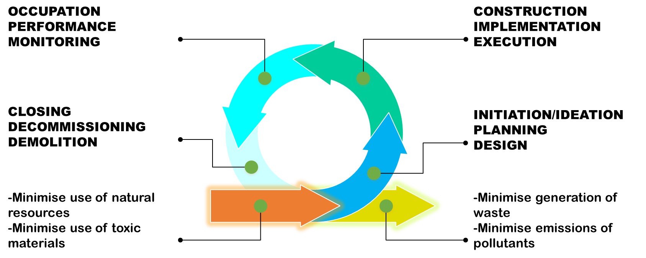
Figure 14: Life Cycle Approach in Construction and Infrastructure
Source: Author (2024)

There are advantages of pursuing sustainable urban infrastructure, including making cities more inhabitable and inclusive; reducing the environmental and carbon footprint; creating green employment; driving green economic growth; evening out inequalities. It is arguable that present-day infrastructure is not prepared to cover even the most basic needs of emerging countries, such as access to running water, sanitation, transport networks, etc., whereas the sustainable alternative could.
Some of the practical policy propositions could include those that target enhancing energy efficiency in construction and infrastructure, including in buildings. This could, for example, respond to whether any renewable energy will be produced in the new or renovated buildings or infrastructure installations; or the use of environmentally friendly heating and cooling systems; or whether it is designed to require zero day time lighting or otherwise reduce energy consumption.
On construction waste, policy options could consider enhanced recyclability of construction materials and environmental friendliness of construction material. How will contractors handle construction and demolition waste? Will they segregate waste, and do they have good waste management strategies? There should be more concerted use of environmental selection criteria for construction material, including sustainability of the material supply chain and material recyclability at the end of building lifetime (Figure 16).

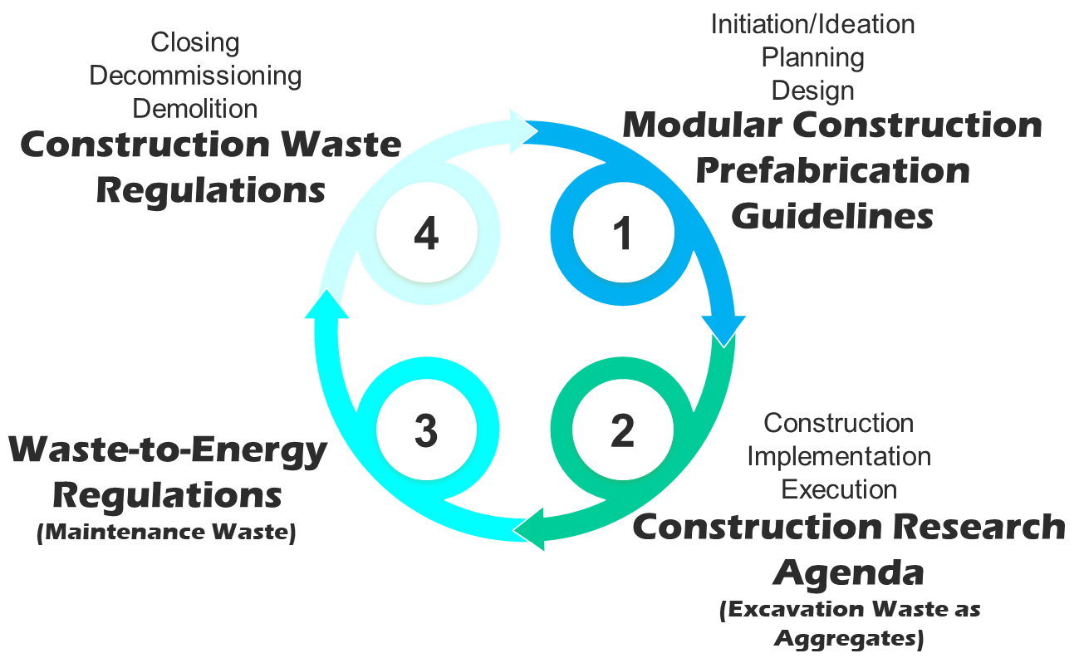

Figure 15: Life Cycle Approach to construction waste management
Source: Author
On water consumption, policy options could include water saving measures, including mitigation of water wastage and enhancement of efficient use of water in construction sites, regulation and implementation of green practices and the like.
There should also be consideration for the establishment of specific environmental management plans where all the measures to prevent, control and monitor construction pollution and natural resource use are contained. Also, environmental monitoring of construction sites as well as training of construction personnel on environmental management requirements and practices; formulation of site waste management plans consisting of actions for different types of waste, expected amounts of every type of waste, and resource allocation to waste management.
Finally, into the future, the coastal counties and the cities of concern herein can consider developing supportive infrastructure for biking programmes and non-motorised mobility to reduce dependence on motor vehicles.

In summary, some of the specific recommendations are provided below:
- Clearly define SCP Targets for the construction and infrastructure sector in the JKP region as a baseline for all subsequent SCP interventions, and set out clear timelines and reporting guidelines for their implementation
- Propose and plan Model Coastal Cities in the three project sites
- Develop Construction Waste Management Regulations to manage construction, demolition and maintenance wastes generated by the construction and infrastructure sector. This shall enhance the move towards zero construction waste, through RRRR (Reduce, Reuse, Recycle/Restore and Return)
- Apply smarter technologies in construction and infrastructure developments, including those that use less water, sand, stones, energy, etc. To this end, develop a Construction Data Management Policy to manage Smart Cities Data; digital platforms for transparency and develop platforms for sharing building materials data, tracking resource use, and promoting transparency in sustainable construction practices.
- Provide incentive schemes to discourage single use wood products such as formwork, scaffolding, props, etc.
- Encourage or enforce use of cleaner and sustainable energy solutions. To this end, develop Waste-to-Energy Regulations to beef up the existing County legal frameworks on solid waste management
- Develop a Construction Materials Research Policy to boost and plug into NCA’s National Construction Research Agenda (NaCRA). It will encourage research into and the uptake of the adoption of low carbon construction technologies, the re-use of construction waste as aggregates, clean construction technology for modular construction, and reduce the proliferation of toxic construction materials in the JKP region
- Implement green certification systems for new constructions and develop a Coastal City Green Index for coastal cities that is adaptive to the conditions peculiar to the JKP region
- Develop a Water and Sanitation Policy for the JKP region that integrates rainwater harvesting in urban planning to reduce freshwater usage and mitigate flood risks through design (porous paving and rain gardens). This policy is to be enacted through JKP Urban Design Guidelines and Building Codes that will define the standards for new buildings, and for retrofitting existing buildings
- Develop and enforce a Bio-based and Recycled Materials Strategy that will encourage construction using bamboo, recycled plastic, and locally sourced materials, reducing reliance on virgin resources and promoting circular economy
- Develop Modular Construction Guidelines that will decrease waste, enhance resource efficiency, and enable faster, cleaner construction. These should be piloted in the affordable/adequate housing initiatives defined in Kenya Vision 2030, JKP Vision 2030, and the CIDPs
- Develop a Green Infrastructure Policy for JKP, and develop Green Infrastructure Guidelines for the JKP. This will integrate green roofs, vertical gardens, and bioswales into buildings to manage storm water, improve air quality, and provide habitat for local wildlife.
- Development of Climate-Resilient Infrastructure and investment in infrastructure resistant to rising sea levels, floods, and extreme weather events, safeguarding coastal communities and minimizing future rebuilding costs. To achieve this a Green Corridor Project is proposed that will entail greening the roads in the Mombasa Metro area and harnessing the potential of roads and highways as the most abundant source of urban open space
- Encourage investment in linear urban forests and tree schemes along roads and highways through the development of a Green Transport Carbon Credits Program to be implemented along roads and highways, that will mirror the proposed JKP carbon credits through mangrove forests conservation.

Figure 17 below summarizes some of the recommendations for construction and demolition waste management that can be applied using the Life Cycle Approach in the Construction and Infrastructure sector.
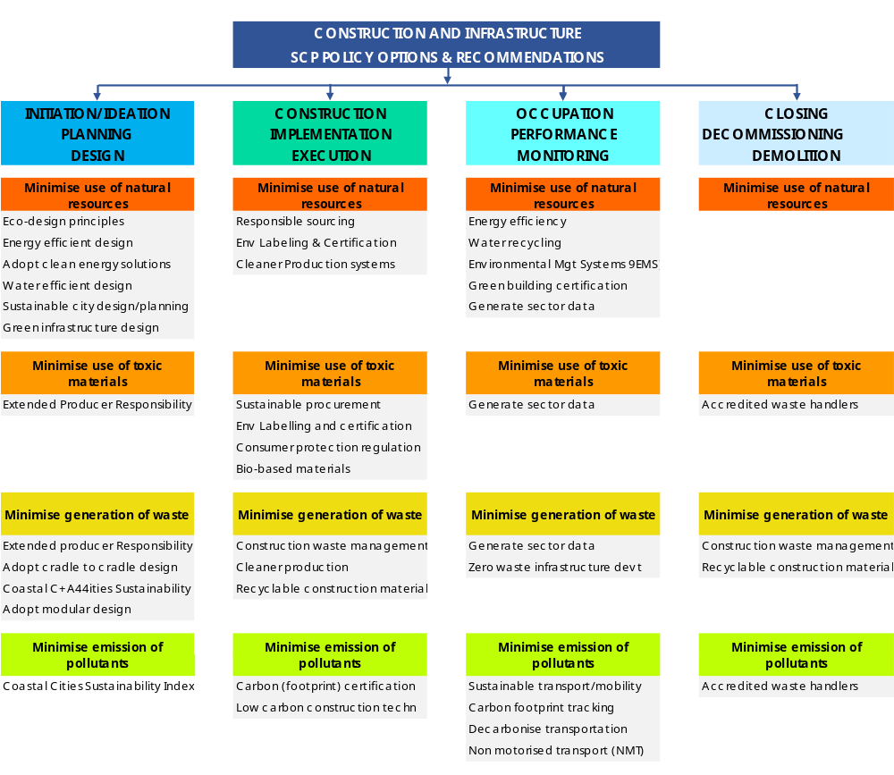
Figure 16: Life Cycle Approach to Policy Options and Recommendations
Source: Author (2024)

REFERENCES
ASEAN Countries Sustainable Urbanization Strategy, available at https://asean.org/book/asean-sustainable-urbanisation-strategy/
Assessment of Impacts of Climate Change on Australia’s Physical Infrastructure (ATSE, 2008) available at https://www.atse.org.au/wp-content/uploads/2019/01/assessment-impacts-climate-change-australias-infrastructure.pdf
Coastal Storm Water Management Through Green Infrastructure: A Handbook for Municipalities available at https://www.epa.gov/sites/default/files/2015-09/documents/massbays_handbook_combined_508-opt_1.pdf
Climate Proofing Toolkit for Basic Infrastructure with a Focus on Water and Sanitation (UN-Habitat, 2021) available at https://unhabitat.org/sites/default/files/2021/09/climate_proofing_toolkit_2021_option_b.pdf
Climate Resilient Infrastructure: OECD Environment Policy Paper No.14 available at https://www.oecd.org/environment/cc/policy-perspectives-climate-resilient-infrastructure.pdf
Compliance to EPR Legislation (NEMA) available at https://www.nema.go.ke/images/Docs/SEA%20Reports/Roll_out_of_EPR_-_producers.pdf
CMS, State of the World’s Migratory Species (2024) available at https://www.cms.int/sites/default/files/publication/State%20of%20the%20Worlds%20Migratory%20Species%20report_E.pdf
Decarbonising road transport – the role of vehicles, fuels and transport demand (European Environment Agency (EEA) Transport and Environment Report 2021 available at file:///C:/Users/HP/Downloads/TH-AL-22-004-EN-N%20TERM%202021.pdf
EPR Implementation Model for Kenya (NEMA) available at https://www.nema.go.ke/images/Docs/EPR%20ACT/EPR%20Implementation%20model%20for%20Kenya.pdf
Future-proofing Infrastructure to address the climate, biodiversity and pollution crises (UNEP, 2021) available at https://wedocs.unep.org/bitstream/handle/20.500.11822/37563/GFB5.pdf
Green Infrastructure Guidelines for Public Projects: Franklin Regional Council of Governments (September 2017) available at https://frcog.org/wp-content/uploads/2019/01/Green-Infrastructure-Guide-for-Public-Works-Projects-2018.pdf
Green Infrastructure Resource Guide (USAID) available at https://pdf.usaid.gov/pdf_docs/PA00TDBD.pdf
Guidance for Including Coastal Green-Grey Infrastructure in NDCs available at https://cicloud.s3.amazonaws.com/docs/default-source/s3-library/publication-pdfs/ci-ggi-policy-brief-v05-fin.pdf?sfvrsn=b738ea70_2
Green Infrastructure for the Coast: A Primer for Local Decision Making available at https://www.crc.uri.edu/download/1.-GRIP-booklet_Final.pdf
Guidelines for Climate Proofing Investment in the Transport Sector: Road Infrastructure Projects (ADB, 2011) available at https://www.adb.org/sites/default/files/institutional-document/32772/guidelines-climate-proofing-roads_0.pdf
ICC, 2018 International Building Code (IBC) (2017) available at https://edufire.ir/storage/Library/exhaust/book/IBC-2018%20ICC%20International%20Building%20Code.pdf
ICC, 2018 International Green Construction Code (IgCC) (2018) available at https://www.ashrae.org/File%20Library/Technical%20Resources/Bookstore/2018-IgCC_preview_1102.pdf
Inter-American Development Bank, the four dimensions of infrastructure sustainability, available at https://publications.iadb.org/en/what-sustainable-infrastructure-framework-guide-sustainability-across-project-cycle
Kenya Country Report on Progress in the Implementation of the New Urban Agenda (NUA) – 31st March 2021 available at https://www.urbanagendaplatform.org/sites/default/files/2022-03/Kenya%20New%20Urban%20Agenda%20Report%20Final.pdf
Kenya National Climate Change Policies: Gaps and Opportunities for Mainstreaming Agroecology in Kenya (2023) available at https://afsafrica.org/wp-content/uploads/2021/10/kenya_report-on-ccp-final-1-24-9-2020-.pdf
Kenya’s Updated Nationally Determined Contribution (NDC) 2020-2030 available at https://unfccc.int/sites/default/files/NDC/2022-06/Kenya%27s%20First%20%20NDC%20%28updated%20version%29.pdf
https://faolex.fao.org/docs/pdf/KEN210108.pdf
Multi-lateral Treaties Deposited with the Secretary- General (as of 31 May 2019) available at https://treaties.un.org/doc/source/titles/english.pdf
Siemens AG, European Green City Index: Assessing the Environmental Impact of Europe’s Major Cities (2009) available at https://assets.new.siemens.com/siemens/assets/api/uuid:fddc99e7-5907-49aa-92c4-610c0801659e/european-green-city-index.pdf
Siemens AG, The Green City Index: A Summary of the Green City Index research series (2012) available at https://assets.new.siemens.com/siemens/assets/api/uuid:cf26889b-3254-4dcb-bc50-fef7e99cb3c7/gci-report-summary.pdf
Tackling Barriers to Green Infrastructure: An Audit of Local Codes and Ordinances (Wisconsin Sea Grant with support from the NOAA Coastal Storms Program) available at https://seagrant.wisc.edu/home/Portals/0/Files/Coastal%20Communities/Green_Infrastructure/GIAT.pdf
UNEP, The Life Cycle Initiative available at https://www.unep.org/explore-topics/resource-efficiency/what-we-do/life-cycle-initiative
UNEP, The REAL Project available at https://www.unep.org/explore-topics/resource-efficiency/what-we-do/life-cycle-initiative/real-project
UN-DESA (2013): Integrated Strategy for Sustainable Cities, Policy Brief No 40, Department of Economic and Social Affairs | Economic Analysis (un.org)
UNDP, Financing Solutions for Sustainable Development, Goal 7: Affordable and clean energy, http://www.undp.org/content/ sdfinance/en/home/sdg/goal-7--affordableand-clean-energy.html
UNOPS- The Critical Role of Infrastructure for the SDGs, https://content.unops.org/publications/The-critical-role-of-infrastructure-for-the-SDGs_EN.pdf
UNEP, ABC of SCP: Clarifying Concepts of Sustainable Consumption and Production (2010) available at https://sustainabledevelopment.un.org/content/documents/945ABC_ENGLISH.pdf
UNOPS- The Critical Role of Infrastructure for the SDGs, https://content.unops.org/publications/The-critical-role-of-infrastructure-for-the-SDGs_EN.pdfWorld Bank, The Costs of Meeting the 2030 Sustainable Development Goal Targets on Drinking Water, Sanitation, and Hygiene: Summary Report, January 2016, https:// openknowledge.worldbank.org/bitstream/ handle/10986/23681/K8632.pdf?sequence=
USAID, Kenya Climate Change Country Profile (2023) available at https://www.usaid.gov/sites/default/files/2023-11/2023-USAID-Kenya-Climate-Change-Profile.pdf
Willar D and others, “Sustainable Construction Practices in the Execution of Infrastructure Projects” (2020) 10 Smart and Sustainable Built Environment 106 https://www.emerald.com/insight/content/doi/10.1108/SASBE-07-2019-0086/full/pdf accessed January 26, 2023
World Bank Group, What a Waste 2.0: A Global Snapshot of Solid Waste Management to 2050 (2018) available at https://openknowledge.worldbank.org/entities/publication/d3f9d45e-115f-559b-b14f-28552410e90a
World Economic Forum, Could infrastructure investment help tackle climate change?, February 2016, https://www.weforum. org/agenda/2016/02/could-infrastructureinvestment-help-tackle-climate-change/
https://www.the-star.co.ke/counties/coast/2022-11-18-97-buildings-under-construction-in-mombasa-lack-approval/
https://www.the-star.co.ke/counties/coast/2022-11-18-97-buildings-under-construction-in-mombasa-lack-approval/

GLOSSARY OF LEGISLATIVE AND POLICY DOCUMENTS
African Convention on the Conservation of Nature and Natural Resources (2003)
Amended Nairobi Convention (2015)
AU, Agenda 2063: The Africa We Want: Popular Version, (2015)
The Basel Convention on the Transboundary Movements of Hazardous Wastes and their Disposals
East African Community, Vision 2050: Regional Vision for Socio-Economic Transformation and Development (2015)
Convention of the African Energy Commission
EMCA, Extended Producer Responsibility Regulations (2020)
Jumuia ya Kaunti za Pwani, 2030 Development Blueprint (2021 Revision)
Republic of Kenya, Kenya Vision 2030: The Popular Version (2007)
Republic of Kenya, Kenya Vision 2030 Flagship Projects Progress Report (2008-2017)
Republic of Kenya, Kenya Vision 2030 Flagship Projects Progress Report (2018-2019)
Republic of Kenya, Kenya Vision 2030 Flagship Projects Progress Report (2019-2020)
Republic of Kenya, Kenya Vision 2030: First Medium Term Plan (2008-2012)
Republic of Kenya, Kenya Vision 2030: Second Medium Term Plan (2013-2017)
Republic of Kenya, Kenya Vision 2030: Third Medium Term Plan (2018-2022)
Republic of Kenya, National Spatial Plan (2015-2045): An Integrated Spatial Plan for Balanced Sustainable and National Development (2015)
Republic of Kenya, Sessional Paper No.1 of 2017 on National Land Use Policy (2017)
Sessional Paper No. 5 of 2016 on National Climate Framework Policy
Transforming our world: the 2030 Agenda for Sustainable Development (2015)
Treaty Establishing the African Economic Community (Abuja Treaty)
County Government of Kilifi: First County Integrated Development Plan (2013-2017)
County Government of Kilifi, County Integrated Development Plan (2018-2022)
County Government of Kilifi, County Integrated Development Plan (2023-2027)
County Government of Kwale, County Integrated Development Plan (2018-2022)
County Government of Kwale, First County Integrated Development Plan (2013-2017)
County Government of Kwale: Draft County Assembly Integrated Development Plan (2023-2027)
County Government of Mombasa, First County Integrated Development Plan (2013-2017)
County Government of Mombasa, Second County Integrated Development Plan (2018-2022)
County Government of Mombasa, Third County Integrated Development Plan (2023-2027)
Kenya National Adaptation Plan (2015-2030)
Kenya National Adaptation Plan (2015-2030): Enhanced climate resilience towards the attainment of Vision 2030 and beyond
Kenya Vision 2030: Fourth Medium Term Plan (2023-2027)
Kenya Vision 2030 Flagship Projects Progress Report (FY 2019/2020)
National Climate Change Action Plan (2018-2022): Volume I
The New Urban Agenda
The Rotterdam Convention on the Prior Informed Consent Procedure for certain Hazardous Chemicals and Pesticides in International Trade
Constitution of Kenya 2010
County Governments Act (Cap 265)
Environmental Management and Coordination Act, 1999 (Cap 387)
Energy Act (Cap 314)
Health Act (Cap 241)
Housing Act (Cap 117)
Irrigation Act (Cap 347)
Kenya Information and Communications Act (Cap 411A)
Kenya Roads Act (Cap 408)
Kenya Roads Board Act (Cap 408A)
Land Act (Cap 280)
Mining Act (Cap 306)
National Construction Authority Act (Cap 118)
Petroleum Act (Cap 308)
Physical and Land Use Planning Act (Cap 303)
Traffic Act (Cap 403)
Urban Areas and Cities Act (Cap 275)
The National Building Code, 2022 (Legal Notice to the National Construction Authority Act, No 41 of 2011)
National Building Regulations, 2015
Kilifi County Disaster Management Act, No 15 of 2016
Kilifi County Health Services Improvement Fund, Act No 16 of 2016
Kilifi County Health Services Improvement Fund Amendment Act, No 1 of 2022
Kilifi County Persons with Disabilities Act, No 3 of 2022Kilifi County Public Entertainment and Amenities Act, No 21 of 2016
Kilifi County Rating Act, No 10 of 2016
Kilifi County Roads and Bridges Act, No 7 of 2015
Kilifi County Transport (Regulation and Control) Act, No 9 of 2016
Kilifi County Vocational Training and Education Act, No 18 of 2017
Kilifi County Water and Sanitation Services Act, No 6 of 2015
Kwale County Disaster Management Fund Act, No 7 of 2016
Kwale County Early Childhood Development and Education Act, No 9 of 2016
Kwale County Public Participation Act, No 12 of 2016
Kwale County Quarrying Act, No 11 of 2016
Kwale County Transport Act, No 3 of 2017
Kwale County Water and Sanitation Services Act, No 2 of 2020
Mombasa County Disaster Preparedness and Emergency Management Act, No 8 of 2017
Mombasa County Education Development Act, No 11 of 2014
Mombasa County Health Act, No 6 of 2018
Mombasa County Public Participation Act, No 6 of 2017
Mombasa County Roads Act, No 8 of 2016
Mombasa County Water and Sewerage Services Act, No 2 of 2016
Kilifi County Spatial Plan (2021-2030)
Kilifi County Spatial Plan: 2021-2030 (popular version)
Kwale Municipal Plan (2023-2032)
Mombasa County Government and JICA, Mombasa Gate City Master Plan: A Premier Gateway Port City that Upholds Diversity and Heritage (2017)

UNEP, The ABC of SCP: Clarifying Concepts on Sustainable Consumption and Production (2010) 44 <https://sustainabledevelopment.un.org/content/documents/945ABC_ENGLISH.pdf> accessed 14 December 2024
UNEP, The ABCs of SCP (n1) 32
UNEP, The ABCs of SCP (n2) 32
Siemens AG, European Green City Index: Assessing the environmental impact of Europe’s major cities (2009) 8
Republic of Kenya, Kenya Vision 2030: The Popular Version (2007) 1
ibid, 2
ibid, 19
Republic of Kenya, National Spatial Plan (2015-2045): An Integrated Spatial Plan for Balanced and Sustainable National Development (2015) 2
Mombasa County and JICA, Mombasa City Gate Master Plan (2017) 6
See Shaban Omar, ‘Kinango residents decry degradation of Samburu-Kinango road’, Star Newspaper, 8 December 2022.
See Kilifi County Annual Development Plans for the years 2020 to 2022
The Constitution of Kenya 2010, Article 61(2).
Ibid, Article 62 (1)(h)
Ibid, Article 62(2),(3).
Ibid, Article 67 (2)(a)
Ibid, Article 67(2)(b).
Ibid Article 64
Ibid, Article 66(1).
Section 3, Physical Planning and Land Use Act, 2019
Ibid, Section 5
Section 9. 10& 11, Kenya Road Act, 2007
Section 3, Climate Change Act, 2016
Kilifi County Spatial Plan 2021-2030, At p. 18
Ministry of Lands and Physical Planning ‘National land use policy’ (2017) Available at https://repository.kippra.or.ke/bitstream/handle/123456789/489/Sessional%20paper Accessed on 9th February 2023
Government of Kenya ‘ Green Economy Strategy and Implementation Plan 2016-2030’ (2016) At p. 22 Available https://faolex.fao.org/docs/pdf/ken170764.pdf Accessed on 9th February 2023
United Nations Intergovernmental Panel on Climate Change (IPCC) ‘AR6 Climate Change: Mitigation of Climate Change, Buildings’ (2014) Available at https://www.ipcc.ch/site/assets/uploads/2018/02/ipcc_wg3_ar5_chapter9.pdf Accessed on 9th February 2023
United Nations Intergovernmental Panel on Climate Change (IPCC) ‘ Climate Change 2022: Mitigation of Climate change’ (2022) Available at https://report.ipcc.ch/ar6wg3/pdf/IPCC_AR6_WGIII_SummaryForPolicymakers.pdf Accessed on 9th February 2023
UN Habitat ‘Green Building interventions for social housing’ (2015) Available at https://unhabitat.org/sites/default/files/download-manager-files/Green%20Building%20Interventions% Accessed on 9th February 2023
Kenya Building Research Centre ‘Mapping of Building Materials in the Coastal Region: Kilifi County’ (2019) Available at https://kbrc.publicworks.go.ke/wp-content/uploads/2020/02/Building-Material-in-Kilifi.pdf Accessed on 9th February 2023
Ibid at p. 44
Ibid at p. 44
Kenya Building Research Centre ‘Mapping of Building Materials in the Coastal Region: Kwale County’ (2019) at p. 10 Available at https://kbrc.publicworks.go.ke/wp-content/uploads/2020/02/Building-Material-in-Kwale.pdf Accessed on 9th February 2023
Ibid p. 6
Willar D and others, “Sustainable Construction Practices in the Execution of Infrastructure Projects” (2020) 10 Smart and Sustainable Built Environment 106 https://www.emerald.com/insight/content/doi/10.1108/SASBE-07-2019-0086/full/pdf accessed January 26, 2023
Ibid
See the ASEAN Countries Sustainable Urbanization Strategy, available at https://asean.org/book/asean-sustainable-urbanisation-strategy/ Accessed on 8th February 2023
See the Inter-American Development Bank, the four dimensions of infrastructure sustainability, available at https://publications.iadb.org/en/what-sustainable-infrastructure-framework-guide-sustainability-across-project-cycle
UN-DESA Policy Brief No 40, Department of Economic and Social Affairs | Economic Analysis (un.org) Accessed on 8th February 2023
Siemens AG, European Green City Index (n2) (2009)
Siemens AG, The Green City Index: A summary of the Green City Index research series (2012)
Vedung describes public policy instruments as “a set of techniques by which governmental authorities wield their power in attempting to ensure support and effect social change” (Vedung 1998, p. 21).
Ibid
UNOPS- The Critical Role of Infrastructure for the SDGs,https://content.unops.org/publications/The-critical-role-of-infrastructure-for-the-SDGs_EN.pdf
World Bank, The Costs of Meeting the 2030 Sustainable Development Goal Targets on Drinking Water, Sanitation, and Hygiene: Summary Report, January 2016, Available at https:// openknowledge.worldbank.org/bitstream/ handle/10986/23681/K8632.pdf?sequence= Accessed on 9th February 2023
UNDP, Financing Solutions for Sustainable Development, Goal 7: Affordable and clean energy, http://www.undp.org/content/ sdfinance/en/home/sdg/goal-7--affordableand-clean-energy.html Accessed on 9th February 2023
World Economic Forum, Could infrastructure investment help tackle climate change?, February 2016, https://www.weforum. org/agenda/2016/02/could-infrastructureinvestment-help-tackle-climate-change/ Available on 9th February 2023
UNOPS- The Critical Role of Infrastructure for the SDGs,https://content.unops.org/publications/The-critical-role-of-infrastructure-for-the-SDGs_EN.pdf Available 9th February 2023
Ibid

